*How to answer A/B testing Data Science interview questions in a way that makes you stand out from the rest.*

A/B Testing is a staple of many data science interviews, especially when the roles deal with deciding how to best design some form of user experience, often through an application or website of some form. Think Amazon, Uber & Youtube -- all these companies have applications with constantly changing features, and behind each change lies an A/B test that is the bread and butter for so many data scientists.

Just do a quick Google search and you’ll find many guides on how to structure a classic A/B testing answer. These guides can be rather useful, but they won’t make your answer stand out from the rest. And that’s what this article is about: I’m going to share with you a thing or two (or three) about how I’ve taken on A/B testing questions in my own data science interview experience and how I make my answer give that extra something that will impress the interviewer. I won’t be covering the basics of formulating hypotheses and conducting t-tests, but I’ll be focusing more on how you can differentiate your answer from the rest.

**What is A/B Testing?**

A/B testing is essentially a controlled experiment to make crucial decisions about product launches, and these changes can range from small elements like the size and color of a button to larger changes like a whole new page on an application altogether.

**Variants**

A/B/N testing, as opposed to A/B testing which only tests two different versions, involves N number of versions being tested at once. A/B/N testing is usually employed for large-scale changes.

Multivariate testing occurs when all permutations of versions and related variables are simultaneously tested, and is often used when combinations of decisions have to be made, instead of running A/B tests on each change.

**Opportunity Sizing**

For many interviewees, they go straight into talking about sample size, statistical significance etc. when asked a question that hints of A/B testing, desperate to unload the memorized frameworks and answers they had memorized in preparation for the interview. However, these answers fall short of standing out from the rest.

Instead, think not just about the techniques of A/B testing, but also about the context in which the A/B testing is conducted. The reality of A/B testing in the real world is that not all proposed changes are worth testing, and in any company there is an element of finiteness that will require a smart allocation of time and resources when it comes to deciding whether a particular A/B testing is worth pursuing.

When the product manager comes to you, the data scientist, with an idea, we want to be able to evaluate the potential impact of this idea based on historical data. This form of opportunity sizing is crucial because it makes your efforts as a data scientist worthwhile. For instance, consider a change on a new e-commerce website that will allow checkout from more than one retailer. To size this opportunity, we need to obtain a ceiling by analyzing the number of different items typically purchased by users. If only a small proportion of users purchase numerous items, this A/B testing might not even be worth pursuing at all. Thus, it is important to estimate the number of users who will actually change behaviors and how this translates to actual numbers for the greater company.

More important, to answer the question about opportunity sizing, you need to be absolutely clear on what metrics you are intending to use. Outline the exact assumptions you’re making in the interview, and be firm about how valuable this opportunity is to be evaluated.

**Metrics**

Metrics, metrics, metrics. Any answer on A/B testing is incomplete if you are not able to comprehensively and confidently talk about metrics. The key to talking about metrics is to know the company’s products well and to research on what kind of metrics will be typically used. For instance, in my own experience interviewing for e-commerce companies, you are often asked to assess a call-to-action feature, such as a pop-up to alert you that a particular offer is expiring.

If you’re evaluating a Call-to-Action feature:

* Click-Through Rate (CTR): Useful for evaluating calls-to-action (CTA, in the marketing industry, is a phrase usually used to induce a response, such as “Find out More” or “Limited Stocks Available”. The CTA aims to provide more reasons to make you, the consumer, make a decision more promptly. The CTR will be the fraction of CTAs that actually resulted in the number of clicks.

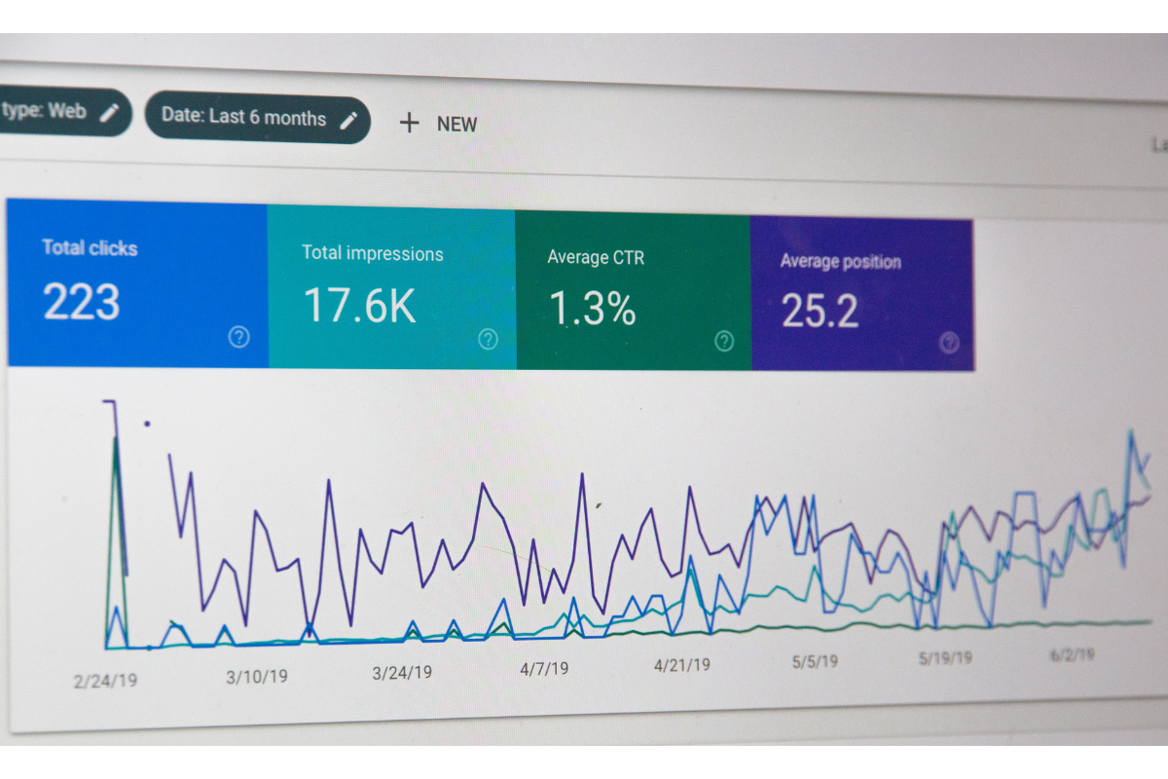

Therefore, the key is to know the application interface well and to understand what metrics tend to be associated with it. Do not just cram all possible metrics into your answers. More importantly, you must never stop at just mentioning the possible metrics that would be relevant. Remember, always answer in context! You have to tell the interviewer why this metric matters and how it matters to the overall user experience.

Some common answers would be the number of followers, number of retweets, likes and mentions. If you want to give a more robust answer, mention something like the click-through rate of tweeted links, or the number of interactions within a fixed time span. A refined answer to the number of followers would be to mention the number of followers who actually turn on notifications for a particular user. Based on my experience, the interviewer does not want you to list all the possible answers you already know. Instead, the interviewer has an ideal answer in mind and you have to think hard about the clues he or she may be giving you along the way.

There are many ways to achieve a holistic answer, but there are two concepts that I never fail to mention: Conversion Funnels and LTVs. A conversion funnel describes the various stages of deliberation and experience that lead up to a final decision point by a user. The term ‘funnel’ is used to illustrate the natural attrition that occurs down the funnel. Always place the selection of metrics in the framework of a funnel, and it will make your answer sound more well thought-out! If you really want to get into the details of conversion funnels, check out this  that talks about seven different types of funnels. Better still, evaluate the long-term view of your metrics using the concept of Lifetime Value (LTV). This tells the interviewer that you think not just about the immediate consequences of a particular design decision, but also how it affects the user in the future and how it may affect other users too (externalities). In fact, I challenge you to go further and talk about how externalities actually violate the assumption of independence between control and treatment groups, and how we might want to control for that.

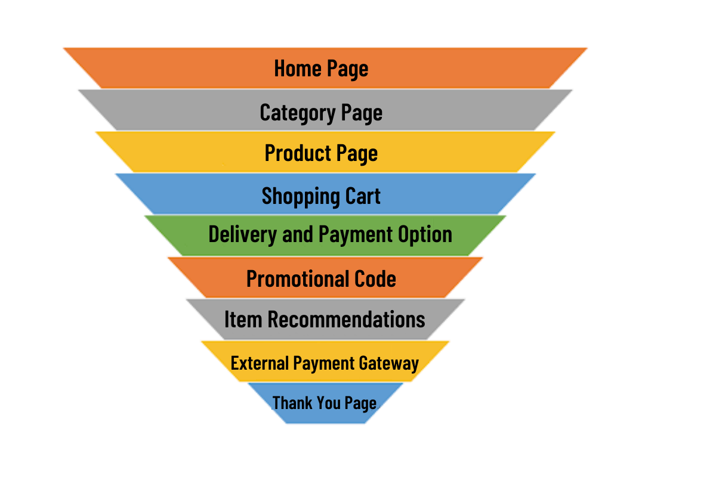

**Sample Size**

Talking about sample size in an A/B testing interview is non-negotiable. In general, the sample size required for the A/B test is dependent on three factors:

1. Power of the test (typically ~0.8-0.9): Probability of rejecting the null hypothesis when the alternative hypothesis is true. Another way to think of power is 1 minus beta, where beta is the probability of a type 2 error, for those of you more familiar with statistical methods.
2. Significance level of the test: The maximum possibility of falsely rejecting the null hypothesis when it is in fact true or type 1 error
3. Minimal Desired Effect (MDE)

The MDE is the minimum improvement over a baseline you are willing to observe. For instance, if we are concerned about observing effects that result in a dollar increase in purchase for every ten dollars spent, we set the MDE to 10%.

In reality, most well-prepared interviewees won’t miss out to mention MDE somewhere in their answers, but the truly brilliant answers will go a step further. In the real world, it’s more efficient to forget about fixing the MDE exactly; instead, we should set limits that will enable better decision making. For instance, holding constant the MDE at 5%, we could calculate how many samples are needed for different levels of baselines. In general, the smaller the baseline, the larger the sample size required to detect the same MDE. Have a think about this to see why this is true intuitively.

**P-value**

What’s a p-value? And how does sample size affect the p-value?

This sounds like a relatively simple question, but you would be surprised by the number of interviewees who actually fumble when asked this question!

The p-value is the probability of finding the observed result under the Null Hypothesis. If you have more data, then the standard error (uncertainty)of the observed result decreases (since SE=std/sqrt(N)) and so the test statistic increases, and so we can have more confidence in rejecting the null. Also, the statistical power of your test (1-(probability of failure to reject the null when it is false) increases. Now, this information can make your hypothesis test stronger (effect size), but it is not related to our interpretation of the p-value.

Here’s another way to think about it. The p-value is a number from 0 to 1 that provides an indication of the level of statistical significance of the test results obtained, as opposed to a test result that is obtained just due to randomness. Specifically, the p-value measures the likelihood of obtaining your test result under the assumption that the null hypothesis is true. Typically, a p-value higher than 0.05 is convincing evidence that we cannot reject the null hypothesis of no effect.

Things get slightly more complicated when we do A/B/N testing, here’s where your knowledge from statistics class will come into use. For instance, if we have 4 treatment groups with one control group, what is the probability of observing at least 1 false positive? (type 1 error) [Hint: It’s not 0.05 * 4]

Here’s the answer:

Pr (FP = 0) = 0.95 * 0.95 * 0.95 * 0.95 = 0.8145

Therefore,

Pr (FP >= 1) = 1 - 0.8145 = 0.1854 (18.54%, NOT 20%)

**Interference**

Finally, let’s talk about interference, that is to say when the assumption of independence is violated between treatment and control groups. In the A/B testing world, everything is ideal because all except the treatment variable is controlled for. However, this ceteris paribus is simply untrue in the real world. This is especially the case for companies like Uber which offer services to users that are so interdependent on each other. Let’s talk about one of these interferences today and how you, as an interviewee, can wow your interviewer by sharing some potential solutions.

For companies like Uber and Lyft which offer two-sided markets, interference will result in what is often known as the overestimation bias, because resources are being co-utilized by members in both control and treatment groups. For instance, if Uber introduces a feature that attracts drivers in our treatment group, this will mean that fewer drivers are available in our control group, and the resultant estimation of the treatment effect will not be accurate.

That’s why the design of the experiment is so important! So what can we do about it? Firstly, we can consider randomizing by location so that we isolate the treatment and control groups sufficiently. By doing so, we prevent the imposition of externalities on the control group when the mechanisms of the treatment group are taking place. But there’s a hidden trade-off here: Isolating groups geographically might result in larger standard errors in our estimation of effects because now each treatment and control group might have more attributes that we are unable to control for. Think, for example, drivers in the central business core versus drivers in the rural areas. Ultimately, trade-offs have to be made and as an interviewee, you will want to mention them. Alternatively, we can randomize groups based on time. This overcomes our shortcoming based on geographical randomization, but only works if the treatment effect is supposed to last for a short time. If instead the treatment effect is meant to capture something like the effects of a peer referral scheme, then perhaps time randomization is not the most ideal.

**50 A/B Testing Interview Questions & Answers**

A/B testing interview questions appear in about ~50% of data science interviews, especially for [Product Data Science roles](https://datalemur.com/blog/product-sense-interview-questions) at consumer-tech companies like [Meta](https://datalemur.com/blog/meta-data-scientist-interview-guide), Airbnb, and Uber. To help you prepare, we've curated a list of 50 A/B Testing Interview Questions and Answers broken into the five main types of questions:

* Experimental Design Questions
* Metric Selection Questions
* Interpretation of A/B Test Results Questions
* Statistical Power Calculation Questions
* Multiple Testing Questions

**Section 1: Experimental Design Interview Questions**

**1. How do you determine the duration of an A/B test?** To determine the duration of an A/B test, consider the following factors:

* Sample size and statistical significance: The primary factor in determining test duration is reaching a statistically significant result. You need a large enough sample size in each variation to confidently conclude that the observed differences are not due to chance.
* Business cycle and seasonality: Consider your business cycle and seasonality when determining test duration. For example, if you're an e-commerce site like [Amazon](https://datalemur.com/blog/amazon-sql-interview-questions), you may need to run tests for at least a full week to capture behavior across weekdays and weekends.
* User behavior and purchasing cycle: Think about your typical user behavior and purchasing cycle. If you're testing a change related to a high-consideration purchase with a long decision cycle, you may need to run the test for several weeks to fully capture the impact on conversions.
* Minimum detectable effect: The smaller the minimum improvement you want to be able to detect, the larger the sample size needed and thus the longer the test duration. If you only care about detecting large effects, you can reach significance faster.

**2. What are some common pitfalls to avoid when designing an A/B test?** Common pitfalls in A/B test design include:

* inadequate sample sizes
* biased sampling methods
* insufficient randomization
* running too many experiments at once

In an interview, you usually want to contextualize your answer about A/B testing pitfalls to the business & team at-hand. For example, if you were [interviewing at Uber](https://datalemur.com/blog/uber-sql-interview-questions) on the Driver Growth division, here are some specific A/B testing issues you might encounter:

* Difficulty isolating variables: Driver behavior is influenced by many external factors like local market conditions, seasonality, competitor activity, etc. This can make it challenging to isolate the impact of a specific A/B test variable.
* Long time to reach statistical significance: Given the long-term nature of driver acquisition and retention, it may take months for a test to reach statistically-significant results on metrics like driver retention and lifetime value
* Potential interference between simultaneous tests: With multiple teams likely running A/B tests concurrently on different aspects of the driver experience (e.g. signup flow, incentives, app features), there is risk of tests interfering with each other and confounding results.
* Ethical considerations with underserved segments: If an A/B test inadvertently provides a worse experience to certain underserved driver segments, even if unintentional, it could have outsized negative impact on those groups.

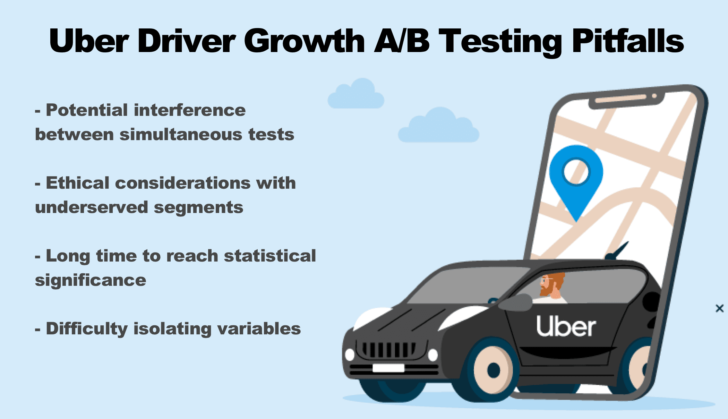

**3. How would you ensure randomization in an A/B test?** Randomization in an A/B test can be ensured by randomly assigning participants to treatment and control groups, thereby minimizing the risk of bias and ensuring that the groups are comparable.

**4. Can you explain the concept of bucketing in the context of A/B testing?** Bucketing refers to the process of assigning participants to treatment and control groups based on predetermined criteria, such as geographic location, device type, or user segment.

**5. What considerations should be made when selecting the sample size for an A/B test?** Sample size for an A/B test should be determined based on considerations such as the desired level of statistical power, expected effect size, baseline conversion rate, and significance level.

**6. What is a control group, and why is it important in A/B testing?** The control group serves as a baseline for comparison, allowing researchers to assess the impact of the treatment by comparing outcomes between the treatment and control groups.

**7. How would you handle variations in user behavior over time during an A/B test?** Variations in user behavior over time can be addressed by conducting the test over a sufficient duration, ensuring that the test period covers different days of the week, times of day, and user segments.

**8. Describe the process of creating treatment groups for an A/B test.** Treatment groups can be created by randomly assigning participants to different experimental conditions or by using stratified sampling methods to ensure that each group is representative of the population. Usually the in-house A/B testing framework at a company like Facebook or Uber is able to do this for you, automatically!

**9. What measures can be taken to minimize the impact of external factors on the results of an A/B test?** External factors can be minimized by conducting the test in a controlled environment, implementing safeguards to prevent interference, and monitoring external events that may impact the results.

**10. How would you determine the statistical significance level for an A/B test?** The statistical significance level, often denoted as alpha (α), is typically set at 0.05 or 0.01, indicating the acceptable probability of falsely rejecting the null hypothesis.

**Section 2: Metric Selection Interview Questions**

**11. What criteria would you use to choose appropriate metrics for an A/B test?** Appropriate metrics for an A/B test should be relevant to the business objectives, sensitive to changes in the treatment, reliable, and actionable.

**12. Can you differentiate between primary and secondary metrics in A/B testing?** Primary metrics are directly related to the primary goal of the experiment, while secondary metrics provide additional insights or context but are not the primary focus.

**13. How would you prioritize metrics when they conflict with each other in an A/B test?** Prioritization of metrics should consider their alignment with the primary goals, sensitivity to changes, reliability, and practical relevance to the business.

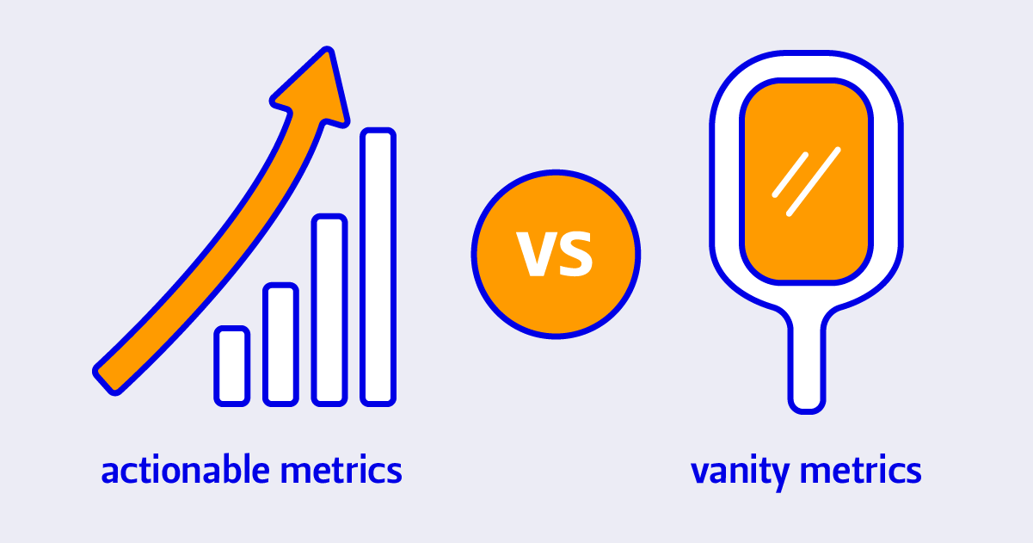

**14. What are vanity metrics, and why should they be avoided in A/B testing?** Vanity metrics are superficial metrics that may be misleading or irrelevant to the business objectives and should be avoided in A/B testing.

For example, imagine you were interviewing for a Product Data Science role at Meta, and had a question about key metrics to track for Facebook Groups. Here's some potential vanity metrics to avoid mentioning to your interviewer:

* Total number of Groups: Tracking the total number of Groups on the platform might seem important, but it doesn't necessarily reflect the health or engagement of those Groups. Many could be inactive or low-quality.
* Total number of Group members: Similar to total number of Groups, tracking total Group membership doesn't account for member activity or engagement. A Group could have many members but low participation. Focusing on this could lead to tactics that drive superficial member growth without improving the Group experience.
* Number of Group posts: Measuring the raw number of posts in Groups doesn't consider the quality, relevance, or value of those posts. This metric could be gamed by encouraging low-effort, spammy posting just to drive up the numbers, rather than facilitating meaningful conversations.

**15. How do you ensure that the selected metrics are relevant to the business goals?** Selected metrics should directly reflect the impact of the treatment on the desired outcomes, such as conversion rate, retention rate, revenue, or user satisfaction.

**16. Explain the difference between leading and lagging indicators in the context of A/B testing.** Leading indicators are predictive metrics that signal future outcomes, while lagging indicators are retrospective metrics that reflect past performance

For example, imagine you were interviewing to be a Data Scientist on Airbnb's Pricing Team. Some leading indicators you could bring up:

* Number of hosts viewing the new pricing recommendations: This measures initial engagement with the new pricing feature and predicts future adoption.
* Percentage of hosts accepting the pricing suggestions: This indicates the perceived relevance and trustworthiness of the recommendations, predicting future usage.
* Change in average listing price: This immediate shift can predict the eventual impact on bookings and revenue.

Lagging Indicators to bring up for the Airbnb Data Scientist Interview:

* Host retention and lifetime value: The long-term impact on host satisfaction and retention on the platform is crucial, but will significantly lag the initial pricing changes.
* Guest reviews mentioning price: An eventual lagging indicator of guest price perception and satisfaction, which could impact rebookings and word of mouth.

**17. How would you handle situations where the chosen metrics may be influenced by external factors?** External factors influencing the metrics should be identified and controlled for, or alternative metrics should be selected that are less susceptible to external influences.

**18. What role does statistical power play in metric selection for A/B testing?** Statistical power considerations should be taken into account when selecting metrics to ensure that they are sensitive enough to detect meaningful differences.

**19. Can you provide examples of quantitative and qualitative metrics used in A/B testing?** Examples of quantitative metrics include conversion rate, revenue per user, and average session duration, while qualitative metrics include user satisfaction ratings and feedback.

**20. How would you measure user engagement in an A/B test?** User engagement can be measured using metrics such as session duration, number of page views, click-through rate, or interaction frequency.

**Section 3: Interpretation of A/B Test Results Interview Questions**

**21. What steps would you take to validate the results of an A/B test** Validation of A/B test results involves cross-checking with other data sources, conducting sensitivity analyses, and ensuring that the observed effects are consistent and robust.

**22. How do you differentiate between statistically significant results and practical significance in A/B testing?** Statistical significance alone does not guarantee practical significance; it is essential to consider the magnitude of the effect and its potential impact on the business objectives.

**23. What factors could lead to false positives or false negatives in the results of an A/B test?** False positives may occur due to random chance or multiple testing, while false negatives may result from inadequate sample sizes or insufficient statistical power.

**24. Can you explain the concept of effect size and its relevance in interpreting A/B test results?** Effect size quantifies the magnitude of the difference between treatment groups and provides context for interpreting the practical significance of the results.

**25. How would you communicate the findings of an A/B test to stakeholders?** Communication of A/B test findings should be clear, concise, and tailored to the audience, highlighting key insights, implications, and next steps.

**26. What considerations should be made when comparing the performance of multiple variants in an A/B test?** Comparison of multiple variants should consider both statistical significance and practical significance, as well as potential trade-offs between different performance metrics.

**27. How do you assess the robustness of A/B test results against variations in data distribution?** The robustness of A/B test results can be assessed by conducting sensitivity analyses, testing alternative hypotheses, and examining the consistency of results across subgroups.

**28. What role does confidence interval play in interpreting the uncertainty of A/B test results?** Confidence intervals provide a range of plausible values for the true effect size, accounting for uncertainty in the estimate.

**29. How would you handle situations where the results of an A/B test are inconclusive?** Inconclusive results may occur due to insufficient sample sizes, unexpected variations in user behavior, or limitations in the experimental design.

**30. Can you discuss the importance of considering practical constraints and ethical implications in interpreting A/B test results?** Consideration of practical constraints and ethical implications is crucial for interpreting A/B test results responsibly and making informed decisions.

**Section 4: Statistical Power Calculation Interview Questions**

**31. What factors influence the statistical power of an A/B test?** Factors influencing the statistical power include sample size, effect size, significance level, and variability in the data.

**32. How would you calculate the statistical power for a given A/B test scenario?** Statistical power can be calculated using statistical software or online calculators based on the desired level of significance, effect size, and sample size.

**33. Can you explain the relationship between sample size, effect size, and statistical power?** Sample size, effect size, and statistical power are interrelated, with larger sample sizes and effect sizes leading to higher statistical power.

**34. How does the significance level affect the statistical power of an A/B test?** The significance level, typically set at 0.05 or 0.01, determines the threshold for rejecting the null hypothesis and affects the statistical power.

**35. What measures can be taken to increase the statistical power of an A/B test?** Increasing the sample size, choosing more sensitive metrics, or reducing variability in the data can help increase the statistical power of an A/B test.

**36. Can you discuss the trade-offs between statistical power and Type I error rate in A/B testing?** Trade-offs between statistical power and Type I error rate involve balancing the risk of false positives with the risk of false negatives.

**37. How would you determine the appropriate effect size for calculating the statistical power?** The appropriate effect size for calculating statistical power depends on the context of the experiment and the magnitude of the expected difference between groups.

**38. What role does variability in the data play in estimating the statistical power?** Variability in the data, measured by standard deviation or variance, influences the precision of estimates and, consequently, the statistical power.

**39. Can you provide examples of scenarios where a low statistical power could lead to misleading conclusions?** Low statistical power increases the risk of Type II errors, where true effects may go undetected due to insufficient sample sizes.

**40. How do you interpret the results of a power analysis in the context of A/B testing?** Interpretation of power analysis results involves assessing whether the chosen sample size provides adequate sensitivity to detect meaningful differences with a desired level of confidence.

**Section 5: Handling Multiple Testing Interview Questions**

**41. What is multiple testing, and why is it a concern in A/B testing?** Multiple testing refers to the practice of conducting multiple statistical comparisons simultaneously, leading to an increased risk of false positives..

**42. How do you control the family-wise error rate in multiple testing scenarios?** Family-wise error rate control methods, such as Bonferroni correction or Holm-Bonferroni method, adjust the significance threshold to account for multiple comparisons.

**43. Can you explain the Bonferroni correction and its application in A/B testing?** The Bonferroni correction divides the significance level by the number of comparisons to maintain the overall Type I error rate at the desired level.

**44. What are some alternative methods for controlling the Type I error rate in multiple testing?** Alternative methods for controlling Type I error rate include false discovery rate (FDR) control and sequential testing procedures.

**45. How would you adjust the p-values for multiple comparisons in an A/B test?** P-values can be adjusted using methods such as the Benjamini-Hochberg procedure or the Šidák correction to account for multiple comparisons.

**46. Can you discuss the trade-offs between different approaches to multiple testing correction?** Trade-offs in multiple testing correction involve balancing the risk of false positives with the potential loss of statistical power due to stringent correction methods.

**47. What considerations should be made when interpreting results after multiple testing corrections?** Interpretation of results after multiple testing corrections should consider both statistical significance and practical significance, as well as potential biases or confounding factors.

**48. How do you determine the appropriate correction method based on the specific A/B test scenario?** The appropriate correction method depends on factors such as the number of comparisons, the correlation structure of the data, and the desired balance between Type I and Type II error rates.

**49. Can you provide examples of situations where failing to correct for multiple testing could lead to erroneous conclusions?** Failure to correct for multiple testing can lead to an inflated Type I error rate and erroneous conclusions about the significance of the results.

**50. How do you communicate the implications of multiple testing corrections to stakeholders?** Communication of the implications of multiple testing corrections to stakeholders involves explaining the rationale behind the correction methods and the impact on the interpretation of the results.

Everybody in the online space has heard the phrase “A/B split-testing”. But many marketers and retailers are hesitant when it comes to conducting their own tests.

**The Ultimate Ecommerce A/B Testing Guide: Strategy, Tactics, Tools, Data Science and Case Studies**

They’re unsure about how to coordinate all the different parts of the split-testing process, from brainstorming to software selection to the analysis of results.

And while A/B split testing isn’t as easy as most people think, it’s far from difficult. Spending some time to implement well-structured and tested A/B split-testing processes will be hugely positive for your online store.

**What is A/B Testing?**

**A/B testing involves driving traffic to two different pieces of content – like ads, emails, web pages, and so on – to see which one performs better.** Often, the only difference between test subjects is a single element such as a headline, CTA ([Call to Action](https://www.growcode.com/blog/call-to-action-cta/)), image, piece of copy, etc. Alternatively, split-tests can be between two completely different content-types, such as Facebook ads, marketing emails, or even entire [sales funnels](https://www.sendx.io/blog/email-marketing-funnel/).

So what do variants “A” and “B” in A/B testing usually represent? Whenever you run a test, you need a **set of “ground level” or “control” results.** “A” typically comprises your current results or the first iteration of your testing variant. “B” is the variation that you will compare the results of “A” against.

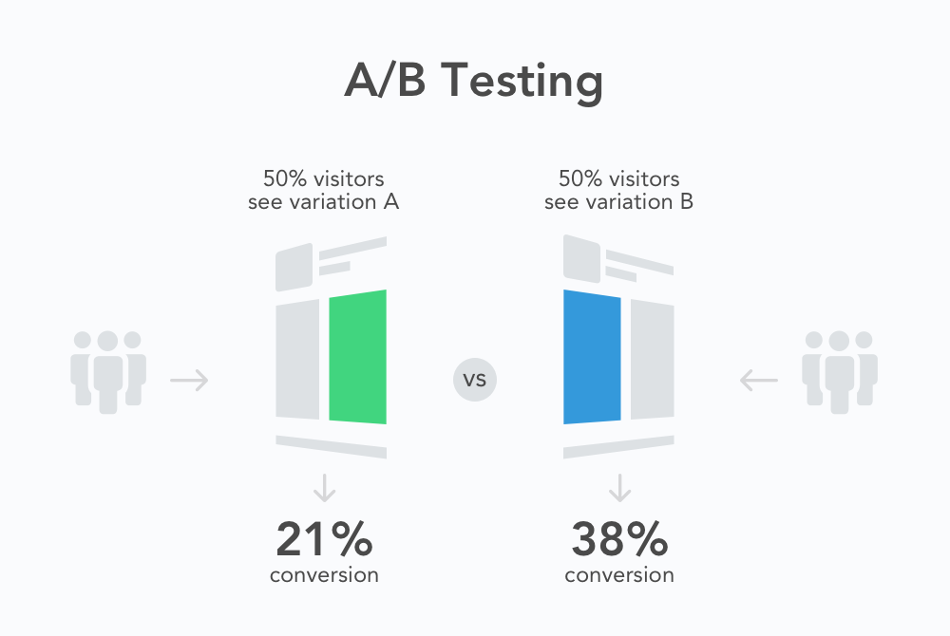A generic example of an A/B test. ([Source](https://splitmetrics.com/resources/what-is-ab-testing-and-why-it-matters-for-mobile-developers/))  
Let’s say, for example, that a product page receives several hundred visitors a day. You decide to run a split-test in which you add a notification about next-day delivery next to the “Add to Cart” button. So, using your A/B testing software, you create a lookalike page and split traffic equally between both pages and measure the results. The current page is test subject “A”. The variant is test subject “B”.

Alternatively, you may be gearing up for a promotional email campaign in which you direct your subscribers to a landing page to enter a free giveaway. You have built two landing pages – “A” and “B” – but you want to see which one attracts more entrants. Again, using your split-testing software, you drive half of the email traffic to page “A” and half to page “B”. Even though you don’t yet have any results, “A” is the control page, and “B” is the challenger.

**“Multivariate testing” works on the same principle but involves testing variants that include multiple changes.** The aim is to determine which combination of variables performs best. In an A/B split-test, for example, you may test a green CTA button against a red one. In a multivariate test, you might change both the color and the CTA text at the same time. In a test with two on-page changes, this would create four variants:

1. color one and text one,
2. color one and text two,
3. color two and text one,
4. and color two and text two.

The benefit of multivariate testing is it removes the need to run lots of split-tests one after the other. The downside is that it requires a lot of traffic.

**How to Do A/B Testing: an Overview**

Let’s look at a basic formula for conducting A/B split-tests. Don’t worry too much about the technical aspect of A/B testing at this stage. There is a range of tools available to streamline and automate everything from page creation to the interpretation of results, and we’ll outline the best apps and solutions in a moment.

**A/B split testing is usually either on-site or off-site.** On-site tests cover things like product pages, landing pages, checkout forms, and so on. On-site tests might also be conducted on the pages of an app – if, for example, you have a mobile shopping or loyalty program app. Basically, “on-site testing” is for any page on your site that has a singular goal and corresponding primary CTA.

**Off-site tests are for variants of ads (especially paid advertisements), emails, social media posts, push notifications, and so on.**

It’s essential to **run tests at the same time with the same traffic sample.** Traffic and time period constitute the two biggest variables that can skew results. There’s absolutely no benefit, for example, in comparing the results of two variants if one was tested on Halloween and the other on Mother’s Day.

[It's essential to run tests at the same time with the same traffic sample. Traffic and time period constitute the two biggest variables that can skew results.**Click To Tweet**](https://twitter.com/intent/tweet?url=https%3A%2F%2Fwww.growcode.com%2F%3Fp%3D4592&text=It%27s%20essential%20to%20run%20tests%20at%20the%20same%20time%20with%20the%20same%20traffic%20sample.%20Traffic%20and%20time%20period%20constitute%20the%20two%20biggest%20variables%20that%20can%20skew%20results.&via=GrowcodeHQ&related=GrowcodeHQ)

Use the following process to structure your own A/B tests:

**1. Analysis**

**In this stage, you determine your goals and prioritize which page elements to split-test.**

Goals will center around boosting your key conversion metrics and **“conversions” might be clicks, sign-ups, or sales.** You might even opt for “broader” success metrics like engagement or reach, especially when testing ads. Whatever the case, you **need a clear metric by which to measure the relative success or failure of variants.**

Once you’ve set goals, you can research and prioritize which tests to run. You should **research those page templates** (product pages, category pages, checkout forms, etc.) that are **most important for your goals and then determine which have the greatest potential for improvement.** Look at pages with high bounce rates, unusually low conversions, low engagement, high abandonment rate and so on.

Once you’ve identified pages which are both important and have potential, you should **rank them according to the ease with which you can run tests.** It’s better, especially when implementing a new strategy, to go **for the lowest-hanging fruit, moving onto more complex tests as you acquire more data.** This methodology will deliver the greatest returns over the shortest period of time.

Your chosen testing element might be a call-to-action, a headline in ad copy, an image on a landing page, a subject line in an email, or a social media post advertising a discount. The critical thing to **remember is that testing subjects should usually constitute one element, with everything else remaining the same.** The exception to this rule is when you are testing two separate variations, such as landing pages or sales funnels which are made up of unique emails and pages.

**2. Recommendations**

After you have identified which tests you want to run, **you need to brainstorm variations and form hypotheses.**

Ask the question, **“Which changes might lead to better outcomes for pages and why?”**

A hypothesis is an evaluation of why a page or element isn’t performing as well as it might and how you might improve it. **When you run an A/B test, you are essentially testing a hypothesis.**

You might conclude, for example, that your current product page CTAs don’t stand out enough and that visitors have trouble finding them. The way to solve this problem would be to use a brighter color for the CTA button.

The best way to formulate hypotheses is to use the following simple template: **If…, then…, because….**

Let’s look at an example:

**If** information about low stock is added to product pages next to the CTA, **then** the add-to-cart rate (and thus the conversion rate) will increase, **because** urgency-building elements prompt visitors to take action.

**3. Prototype and Design**

After forming hypotheses, many people jump in and start organizing the test. But it’s essential to **properly brainstorm and verify different design options, ensuring that the whole team is on board and that all ideas are accounted for.**

You should begin by creating loose wireframes of proposed changes, brainstorming as many possibilities as is feasible. After verifying those that seem most promising, you can create full prototypes for implementation purposes.

**4. Code and Test**

**Begin by calculating your sample size.** Your “sample size” is the **amount of traffic** you need to conclusively say that any differences in results are not due to chance. We cover this topic in-depth in the next section. If you are not currently driving high levels of traffic to a specific page, or your site is in the development stage, **you can always buy traffic.** Many services exist for this purpose.

Then, with the **groundwork in place, you can select the right tools and begin the test.** Different tools serve different testing needs. **For individual page elements, a simple web editor is all that’s needed.** For more complex split-tests, such as a comparison of different sales funnels, sophisticated tools may be required. Dedicated software is also available for email marketing and ad campaigns.

If you have a dedicated development team for implementing on-site code, the designs you created in the previous step will prove invaluable here.

**5. Results**

**Once the test has run its course, you can evaluate results and formulate new split-tests. Evaluation has two purposes: to determine a winner and generate new ideas for future tests.** Sometimes results will be inconclusive, causing you to revise or abandon your original hypotheses. In other cases, results will be so significant as to prompt similar tests on other related pages or **try even more advanced variations of your original change.**

Split-testing is best conducted as part of a longer-term strategy. You should aim to make lots of small changes over many weeks and months. All of these changes will add up to dramatically and consistently improve your overall conversion rate.

**How to Calculate Your A/B Split-Testing Sample Size**

Calculating your minimum sample size is relatively easy once you understand the underlying concepts.

Here are a few terms you’ll need to know:

* **Baseline conversion** – The conversion rate for your current page.
* **Minimum detectable effect** – The minimum detectable effect is the minimum percentage change from the baseline conversion rate that you feel excited about: it can be 2%, 3%, 5% or 10%. In A/B testing it should rarely be above 10%. Of course, **smaller uplifts are easier to achieve but harder to prove because you will need more users.** On the other hand, bigger uplifts are easier to prove with fewer users. But it’s usually difficult to come up with a testing idea that is going to have such a profound impact.
* **Statistical significance** – Statistical significance is the degree to which **you are “sure” about your results.** In an ecommerce setting, you should aim for 80% to 95% statistical significance.
* **Significance level** – Significance level is the **inverse of statistical significance.** A 5% significance level, for example, means that there is a 5% chance that results are due to random chance. A 5% to 20% significance level is normal.
* **Statistical power** – Often sidelined by A/B split-testers, **“statistical power” is the percentage that describes the probability that a test will find the minimum detectable effect, assuming it exists.** For example, say you set the minimum detectable effect to 5% and statistical power to 80% and, at the end of the test, your alternate version doesn’t win. You have 80% certainty that the losing version is not better by 5% or more.

**Which Product Page Elements Should You Split-Test?**

Product pages fit the criteria for picking testing candidates perfectly. They are among the most important and highest-traffic pages on an ecommerce site. They’re also easy to split test.

Here are some of the product page elements which can have the greatest effect on conversions:

* **Title** – The title is the first thing that customers see when they land on a product page. It identifies the item and distinguishes it from other products. You can experiment by including (or excluding) brand names, key features, and USPs, and sampling different versions of the generic product name.
* **Images** – Product images can significantly affect conversions. In particular, the flagship product image – the one that customers see first before scrolling through subsequent images – carries a lot of weight. Run different variations of this image to see which one customers find most appealing.
* **Description** – Persuasive descriptions compel customers to click the primary CTA. Experimenting with descriptions by adding persuasive elements to your copy can yield interesting results. Consider citing awards, mentions in the media, celebrity endorsements, stand-out reviews, and more.
* **Price** – Virtually every single visitor to a page will look at the price. Numerous changes can be tested, including color, size, location, and any information included immediately next to the price – such as the original struck-through price before discounts or a deadline for a promotional price.
* **Feature Options** – Often, visitors will need to select item features like color and size before purchasing. If these options are unclear or difficult-to-use, it can create a lot of friction for buyers. Ambiguous stock levels can also lead to uncertainty.
* **Delivery information** – Shipping **time and cost** is another major factor in the decision-making process. You can eliminate doubt by showing delivery information in the right way, and even increase willingness to buy by prominently showing free, same-day, or next-day delivery.
* **CTA** – This is a big one. Three features are most important when it comes to CTAs: **shape, size, and color.** CTAs should stand out from other elements on the page and be easy to click, especially on mobile.
* **Star rating** – Online purchasers love reviews. Consider testing variants of a star rating shown underneath your headline and make it easy for customers to navigate the section on product pages dedicated to reviews.
* **Urgency-building features** – Urgency-building elements – like countdown-timers, time-limited delivery, special discount prices, and so on – can dramatically boost a page’s conversions. Learn more about [building urgency on product pages](https://www.growcode.com/blog/create-urgency-ecommerce-product-pages/).

**Top 11 Ecommerce A/B Split-Testing Mistakes to Avoid”**

When not done correctly, split-testing can be a colossal waste of time and money.

Avoid making the following mistakes:

1. **Split-testing pages that don’t affect conversions** – There’s no use in split-testing pages that don’t affect conversions in a significant way. With limited time and resources, it’s crucial to research and prioritize the best candidates for testing.
2. **Split-testing multiple elements in one test** – If you run tests with multiple elements, you have no way of knowing which variations are responsible for positive results. This negatively affects your ability to formulate hypotheses going forward and is also likely to lead to less-than-optimal results for the pages you ran the tests on.
3. **Using a small sample size** – If you don’t adhere to good data science – calculating a sample size with statistical significance of between 80% and 95% – your results will be inconclusive. Over the long-term, this will more likely than not lead to negligible changes to your goals.
4. **“Borrowing” all your testing ideas** – Competitor research and the use of case studies to inform your hypotheses is good practice. It’s a mistake when you only generate testing ideas from them. Many of your best results will likely come from tests that your competitors haven’t conducted.
5. **Sporadic split-testing** – As the old saying goes: split-testing is for life, not just for Christmas. For the greatest conversion gains, and for a strategy that is able to adapt to shifting consumer behavior, testing should be conducted in a sustainable manner over the long-term.
6. **Lack of separation between design and development processes** – There should be a clear distinction between tasks when it comes to brainstorming ideas (design) and implementing them (development and coding). Often, retailers will confuse these roles, resulting in either ineffective brainstorming or shoddy implementation. Even if one person is responsible for both jobs, it’s essential to ensure they have the appropriate skill sets.
7. **Basing hypotheses on hunches and assumptions** – Every split-testing team will have a set of assumptions about what makes a “good testing idea”. But it’s important to be as open-minded as possible and create hypotheses that might seem counter-intuitive. The whole purpose of split-testing is to identify positive original changes. Processes should challenge underlying assumptions as much as possible and encourage designers to think outside the box.
8. **Failure to form proper hypotheses** – It’s important to know the reasons behind positive changes. If you generate ideas without any forethought, you’re putting yourself at a disadvantage. Understanding the basis of successful outcomes enables you to formulate a clearer understanding of the behavior of your customer base over time and generate solid hypotheses going forward.
9. **Inadequate analysis of results** – So CTA “B” converts at 10% while CTA “A” only converts at 5%. That’s the end of the story, right? No! Test data holds useful insights about customers, including information about high-converting segments, peak conversion times, on-page obstacles, and more. Use an analytics platform like Google Analytics to really drill down into test results.
10. **Overlooking small gains** – Retailers often expect massive results and often discount 2% or 3% changes as insignificant. In a way, this is understandable. The preponderance of ultra-successful case studies on the web has conditioned us to try and mirror the same results. But this is a mistake. Small increases, when they have robust statistical significance, are just as valid as larger results. Tests that have high statistical power can detect a small effect and are all equally valid.
11. **“Peeking” into results** – Stopping split-tests prematurely (before you have attained your desired number of tested users) is a [big no-no](http://blog.analytics-toolkit.com/2017/the-bane-of-ab-testing-reaching-statistical-significance/). Often, testers will conclude the efficacy of one variant over another based on results mid-test. When you do this, you ignore variance that can manifest over the course of a test, and it’s common for variations to arbitrarily outperform each other at certain times.

**A Review of the Best A/B Split-Testing Tools for Ecommerce**

**A/B split-testing should encompass most aspects of your marketing and sales activities.** It shouldn’t be limited to your site. Most dedicated apps, such as those for your email marketing, Facebook advertising, social media, and so on, will come with their own A/B split-testing tools.

This list outlines the best tools for running split-tests **on your ecommerce site**. Furthermore, there isn’t an all-out “best” tool when it comes to A/B split testing. Different solutions are designed for different types of online stores, and the best choice of software depends on a range of factors, including size, industry, preferred marketing methods, and more.

Here’s our rundown of the top five ecommerce A/B split-testing tools:

1. [**VWO**](https://vwo.com/)**–** VWO is one of the most popular ecommerce tools on the web for **conducting analysis, developing new ideas, and running tests.** As a platform, it has all the features needed to run optimization campaigns and is very versatile – with a range of options for enterprise companies and smaller businesses (and everything in between). VWO includes eBay on its client list.
2. [**Optimizely**](https://www.optimizely.com/de/) – Another big name in the  international ecommerce space, Optimizely is a**favorite among “big name” online retailers**. The software includes a powerful package of features for conducting A/B tests, allowing for segmentation of samples, forecasting, targeting, and analysis. It’s perfect for use on both mobile and desktop.
3. [**Google Optimize**](https://optimize.google.com/optimize/home/#/accounts) – One of the big selling points of Google Optimize is its seamless integration with Google analytics, although “selling-point” is perhaps the wrong word since it’s free. Optimize is a full A/B testing platform and has its own visual editor. It’s found a large following mostly among smaller companies, which is understandable given that it lacks many of the enterprise-level features of competitors. There is a paid version, Optimize 360, which users can upgrade to at a later date.
4. [**AB Tasty**](https://www.abtasty.com/) – AB Tasty has been designed for larger enterprises and comes with a full set of testing tools, including a feature-rich analytics platform, visual editor, and automated implementation functionality for running tests.
5. [**Swiftswap**](https://www.growcode.com/#homepage-swiftswap) – We couldn’t compile a list of the top testing tools without including Growcode’s software, Swiftswap. What makes Swiftswap unique is its use of AI to inform and streamline the testing process. It integrates with all ecommerce platforms. It’s also designed to deliver fast and consistent optimization changes to ecommerce stores and is available as part of Growcode’s outsourced optimization package.

**Examples of Ecommerce A/B Testing Case Studies**

So what does an A/B split-test look like in practice?

Here are three examples from Growcode’s own case files:

[**1. Budapester**](https://www.growcode.com/budapester-mobile-conversion-rate-optimization-spcs/)

Budapester is a large online retailer that sells designer bags, shoes, and accessories. The company wanted to implement a long-term testing plan that was cost-effective. Analysis showed that product pages and the shopping cart had the greatest potential for improvement.

**Result: Conversion rate increased by 12.5%.**

The following hypotheses were formulated and tested:

Hypothesis one: clearer communication of the USP on all pages would boost conversions.

**Before:** The USP, which includes free shipping and immediate product availability, was not shown on product pages.

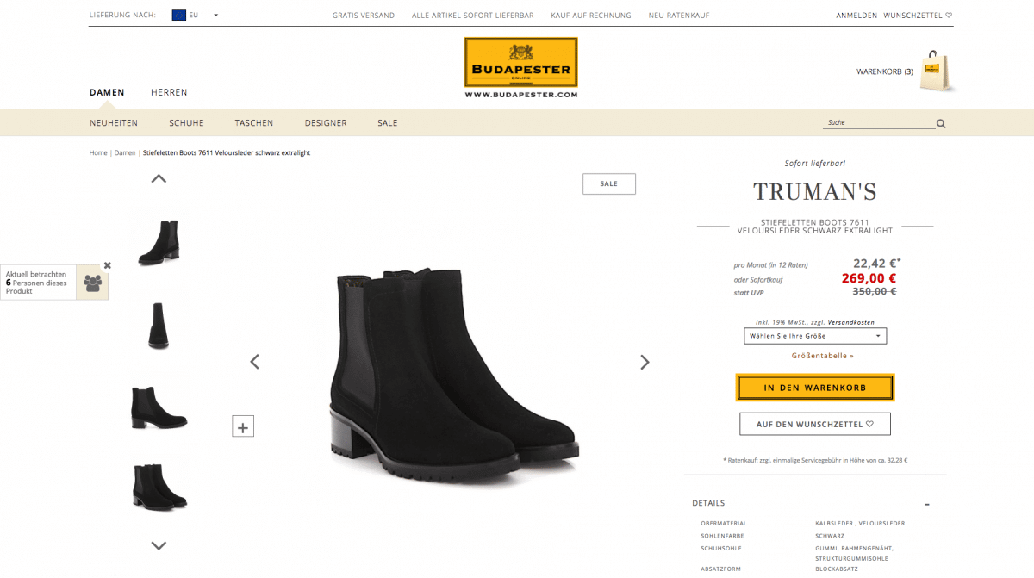

**After:** The USP was included below the product description and in the header.

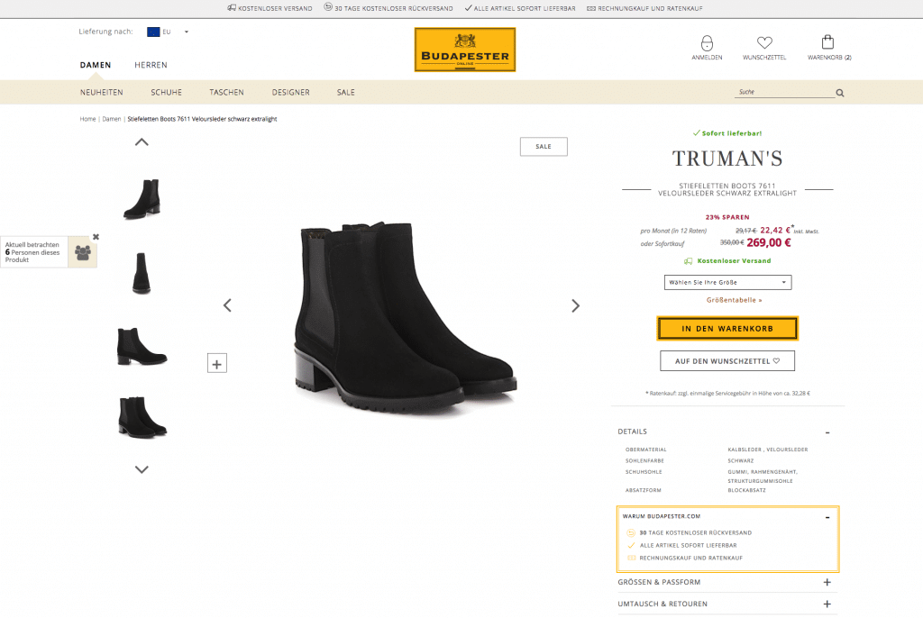

Hypothesis two: the header was taking up too much space and distracting visitors with unnecessary links and information.  
**Before:** The header was unclear, with lots of small buttons, hard-to-read text, and unnecessary links.



**After:** The header was simplified and the main buttons were made clearer.



Hypothesis three: a streamlined shopping cart would reduce cart abandonment.  
**Before:** On the purchase confirmation page, information about free delivery was not shown and discounted prices were not highlighted.

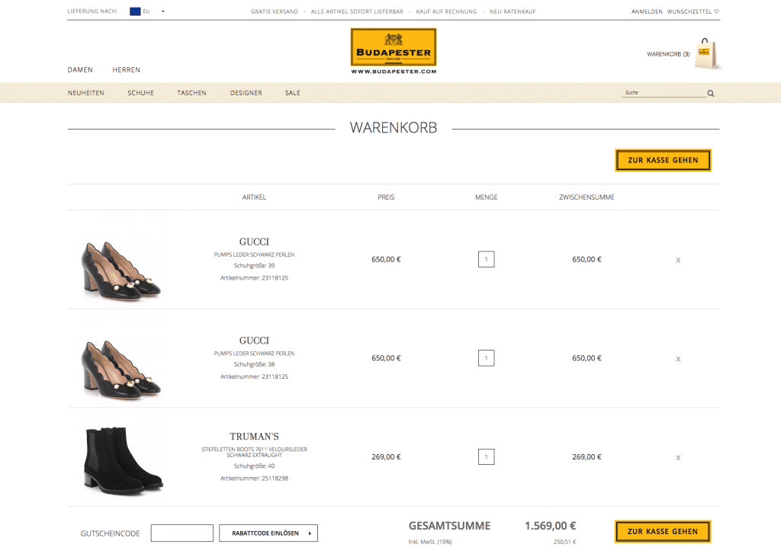

**After:** Free delivery, availability, and discounts were all included in bright colors to make them noticeable.

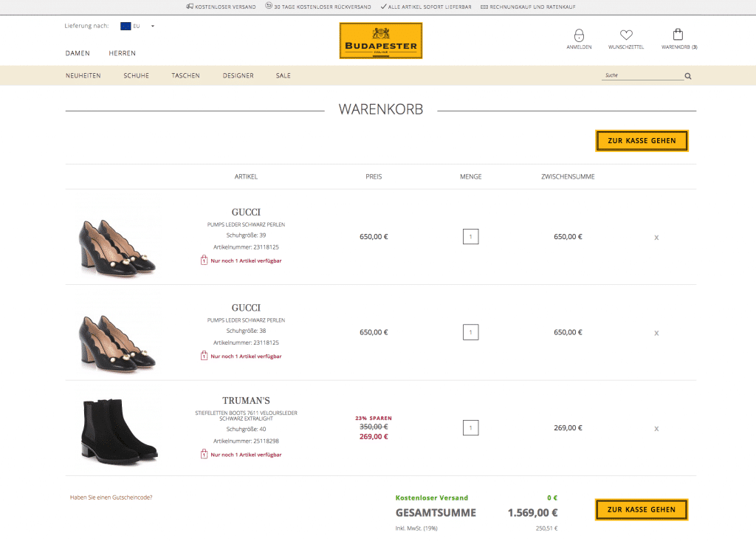

[**2. Reserved**](https://www.growcode.com/reserved-ecommerce-optimization-spcs)

Reserved is the biggest fashion retailer in the CEE region. The online store was launched in 2013.

**Result: 4.6% conversion rate increase.**

[Read the full case study here.](https://www.growcode.com/reserved-ecommerce-optimization-spcs/)

The following hypotheses were formulated and tested:

Hypothesis one: Adding the USP to main pages – home page, product pages, and category pages – would help to persuade visitors of the unique benefits of shopping with Reserved.

**Before:** No clear USPs were displayed on the home page.



**After:** The USPs were displayed on the homepage just underneath the header.



Hypothesis two: Including the USP on shopping cart pages would reduce cart abandonment.  
**Before:** Certain USPs were shown, but they were not clearly explained. Information about free delivery and free courier delivery on purchases over $50 was not shown.

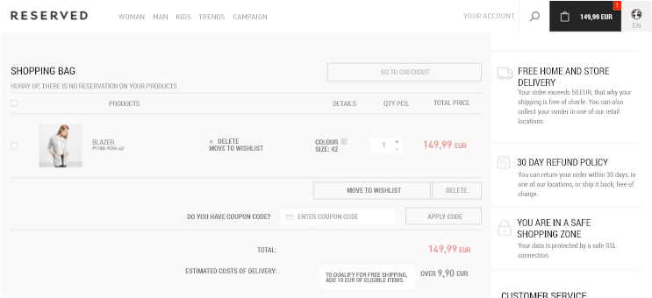

**After:** A section displaying information about USPs was included on the right of the page.

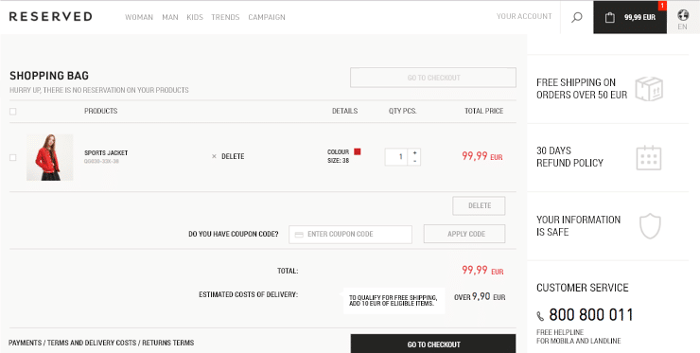

[**3. 4F**](https://www.growcode.com/4f-ecommerce-optimization-spcs/)

4F sells sportswear and sports accessories. The company has built a reputation for quality – mixing traditional manufacturing processes with modern designs.

**Result: 8% global conversion rate increase.**

The following hypotheses were formulated and tested:

Hypothesis one: Including detailed descriptions on product pages will alleviate doubt and prompt more visitors to add products to the cart.

**Before:** Product information was scattered, difficult to scan, and far away from the CTA.



**After:** Product details, including delivery information, were written to be scannable and placed next to the CTA.

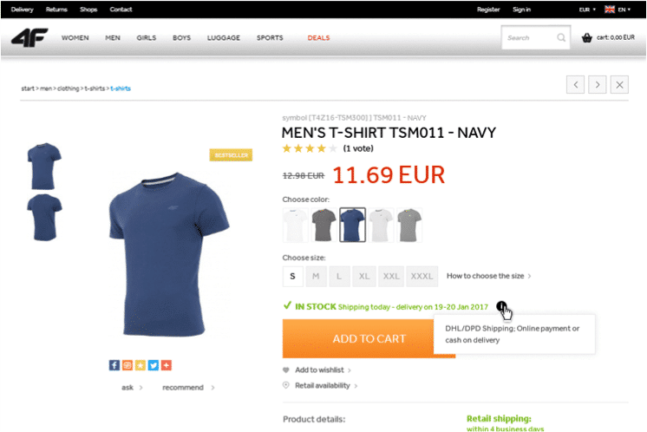

Hypothesis two: Showing discounts as a percentage will prompt more customers to add products to the cart.  
**Before:** The discounted price was struck-through and shown next to the current price, with no further information.



**After:** A figure showing the discounted price as a percentage was included next to the current price.



Hypothesis three: Showing information about in-store delivery would boost conversions because it is highly relevant to customers and 4F has a well-known chain of local stores.  
**Before:** Information about store delivery was quite far down the page.

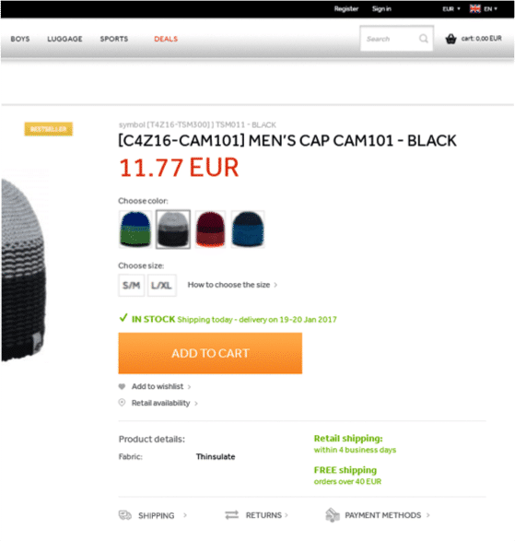

**After:** Direct shipping and in-store delivery details were displayed next to each other above the CTA.

**22 A/B Testing Interview Questions & How to Answer Them**

22 real-life examples of A/B testing interview questions—and how to answer them

Below is a representative sample of questions we have asked or have been asked in A/B testing interviews. As a [**digital optimization**](https://amplitude.com/digital-optimization) company, our questions are slightly biased toward the context of [**using A/B testing**](https://amplitude.com/blog/ab-testing) to build and [**grow a product**](https://amplitude.com/blog/product-led-growth).

You’ll find questions and answers for both [**product management**](https://amplitude.com/blog/product-management-process) and [**data scientist**](https://amplitude.com/blog/8-data-science-skills-that-every-employee-needs) roles, as well as questions that assume that the hiring process has already verified basic knowledge of A/B testing.

Experiment design and setup

Most interviewers will start with foundational questions about A/B best practices. This is your chance to prove you know the fundamentals—after all, a solid foundation is necessary for a successful test. These questions are a bit of a warm-up and a chance for you to practice giving answers that show your thought process.

1. What are the ideal conditions for A/B testing?

A/B tests are the best tool for the job when you’ve just launched a major website or product update or when you have a specific metric you want to boost. They work best for features or elements many people are interacting with (to ensure a sufficient sample size).

2. What should you test?

Strictly speaking, A/B tests only involve one variable (multivariate tests are their own thing). An A/B test is run like a scientific experiment: First, you identify the metric you’re targeting, then use your knowledge of your customers to make an educated guess on what variables to change.

**Tip**

Tell a story about how you chose the metrics and variables in a test you’ve run and your process for choosing them.

3. If A/B testing is not an available option, how would you answer a question instead?

Basic [**behavioral tracking**](https://amplitude.com/blog/behavioral-analytics-definition) can help show what customers respond to (or don’t like). Heatmaps or scroll maps are one simple example; you may opt for more detail with a full session recording. If you have the resources for it, running a [**product feature analysis**](https://amplitude.com/blog/ultimate-guide-product-feature-analysis) helps your team understand how customers engage with your product. You can also collect direct feedback via customer surveys or interviews.

4. How long would you run an experiment for?

Two weeks is a sufficient minimum length for any A/B test, giving you enough time to gather data during the weekdays and weekends. Beyond that, it depends on the sample size (which is always determined during the experiment design phase). Tools like Amplitude’s [**duration estimator**](https://amplitude.com/docs/experiment/workflow/experiment-estimate-duration) provide a starting point when designing an experiment. You can also use our [**statistical significance calculator**](https://amplitude.com/calculate/statistical-significance) to check whether or not the test results are real.

Well-designed tests account for user behavior. If you’re testing a feature, such as reporting, that some teams typically access once a month, you’ll want to extend the duration so you can include those infrequent users in your results.

A/B testing tools

Companies want to know whether you can hit the ground running, so proving your first-hand experience with common tools is necessary.

5. What A/B testing software do you recommend and why, based on your own experience?

We hope you’ll say, “Amplitude” here, but there’s no right answer to this question. When discussing the “why,” consider factors like usability and integrations alongside features.

6. How would you learn a newer A/B testing tool like [**Amplitude Experiment**](https://amplitude.com/amplitude-experiment)?

This is meant to explain how well you’ll adapt to how your new team works. Remember the first time you picked up whatever tool you are working with now? Pairing your methods with illustrative anecdotes will show you’re not just speaking hypothetically.

Resolving experimentation issues

Hiring managers want to see you have practical experience running A/B tests and that you’re capable of a measured response when things don’t go as expected.

7. How do you deal with small sample size issues?

Because we [**calculate sample size**](https://amplitude.com/calculate/sample-size) based on our desired baseline conversion rate, confidence level, and minimum detectable effect, these are the factors to look at when your sample size is much smaller than you’d like. We might decide that an A/B test with less certain results is better than no test at all.

You could look for a higher confidence level or a lower minimum detectable effect. You might also use [**Bayesian (rather than frequentist) statistics**](https://amplitude.com/blog/frequentist-vs-bayesian-statistics-methods), especially if you already know how your customers tend to interact with your site or software.

**Tip**

If you haven’t discussed alternatives to A/B testing yet in your interview, weave them into your answer to show that you can think outside the box.

8. What issues could impact your A/B test results in the development cycles of our product?

Timing matters for A/B tests: Testing too early might result in a small sample size, whereas testing too late may mean providing a suboptimal experience for months. Tests constrained by time may result in a small sample size or otherwise lower-quality data.

There’s also the question of whether tests might affect each other. Even if there’s no direct overlap between the features you’re testing and the [**metrics you’re tracking**](https://amplitude.com/blog/15-important-product-metrics), the differentiation between [**customers’ experiences**](https://amplitude.com/blog/customer-experience) might skew your results.

9. How do you mitigate these issues?

Mitigating these technical issues requires effective communication between the data science and product management teams.

Data scientists will consider questions like: Can we do this with a smaller sample size? Can we have multiple tests going simultaneously and maintain confidence in our data?

PMs must ask: What is the lowest level of confidence I’d feel comfortable working with? Can we tweak our roadmap to enable a schedule that rules out potential interference?

Before proposing a new test, either party can ask: Are we running this test because we have a clear hypothesis we want to examine?

**Tip**

Add a story about a time you didn’t get everything you wanted when planning an A/B test. Share the process you went through when deciding what to compromise on and what you learned from the results.

10. How do you design a test to minimize interference between control and treatment?

Minimizing interference between control and treatment groups in an A/B test means looking for (and avoiding) indirect and direct connections. Because direct connections involve an individual in the control group interacting with an individual in the treatment group, it’s best first to identify network clusters among your users. Then, assign customers not individually but as clusters.

Indirect interference is harder to spot—sometimes, it’s caused by shared resources, and other times, there are other variables that aren’t immediately obvious. The best way to avoid this problem is to use a different interval of time for the control and treatment groups.

Common A/B testing scenarios

Organizations are likely to ask about your experience with A/B testing, especially regarding their product. Because these answers are based on your specific situation, we’ll tell you what to focus on when crafting your answer.

11. Tell us about a successful A/B test you designed. What were you trying to learn, what did you learn, and how will the experience help you if you work for us?

Interviewers want to learn about your process, so start in the pre-experiment phase and take them all the way through to the data you found and how you interpreted it. Don’t focus on the test results when talking about how the experience will help you—trends among your customers may not apply to this company’s customers. Instead, share some things you think you could do differently or better in the future.

12. From your experience with using our product, what improvements would you suggest, and what experiments would you set up for them?

Prepare for this question by interacting with the company’s product for at least 10 minutes. Then, ask yourself what the company’s key business objectives likely are and what metrics relate to those. These are the metrics you’d be targeting in an A/B test; from there, it should be easy to find potential features to iterate.

**Tip**

You can always ask for more information to inform your answer—in this case, by sharing your assumed business objectives and then asking your interviewer to confirm or share a more important KPI. This will enable you to give a more relevant answer and demonstrate your understanding of how A/B testing fits into larger business goals.

13. Let’s say we want to compare Feature A and Feature B in an experiment for user flow. How would you go about designing this test, given what you know about our product?

Be ready to define a potential hypothesis and metrics that would matter to this test. From there, take your interviewers through your process: Describe variations you’d create (if necessary) and then share potential issues you’d want to watch for. Interviewers want to know you’re actively thinking about how to get useful data.

14. How do you deal with super long-term metrics where you have to wait two months to get your metric? For example, when you try to test how much money people spend during the two months after seeing a feature?

Long testing times can introduce complications, and this question addresses how you can handle them. Be ready to discuss potential shifts in data caused by novelty, primacy effects, or customer-side changes like deleted cookies and evolving needs. There’s also the threat of interference with overlapping tests, which you’re more likely to run the longer a test goes on. Don’t forget to address how you’d justify your decision to impatient PMs or other stakeholders pushing you for quicker results.

Data analysis and decision-making

Gathering valid data is one skill; [**gleaning useful insights**](https://amplitude.com/blog/question-the-data-how-to-ask-the-right-questions-to-get-actionable-insights) from it is another. Interviewers want to understand your thought process when making sense of your A/B tests.

15. What would you do if your experiment is inconclusive and looks more like an A/A test? How would you [**analyze the test results**](https://help.amplitude.com/hc/en-us/articles/115001580108-Analyze-A-B-test-results-in-Amplitude), and what would you look into?

The first step after receiving an inconclusive test result is to look closer at the data to ensure it hasn’t been polluted. Also, make sure your audience was properly segmented and that no other tests or factors interfered with your experiment.

If your test was sound, look at secondary metrics—as long as they’re ones you previously defined, not ones you’ve cherry-picked. Then, segment data: Look at mobile users vs. desktop users and new vs. returning audiences. And make sure to segment any data that might have been affected by a simultaneous test.

Finally, ask yourself what an inconclusive test means: What have you disproved?

16. When you know there is a social network effect and the independence assumption doesn’t hold, how does it affect your analysis and decisions?

For social network tests where an independence assumption does not hold, the effect is amplified. The network effect brings the control and treatment closer together because one group affects the other.

Say the treatment group performed 2% better than the control—that data is what you saw *after* the control group’s behavior was affected, which means it’s skewed toward the treatment group’s results.

17. In our A/B test, the results were not statistically significant. What are some potential reasons for this?

It’s always possible the variable you were testing didn’t affect customers’ behavior, and you want to keep this in mind before you waste time going down rabbit holes. However, design issues like a small sample size or insufficient statistical power can lead to a statistically insignificant result. If you’re seeing a lot of variance in your key metric, it may be worth revisiting your metric or implementing stratification

18. What do you do when you’re testing for two metrics and aim to increase both, but one increases with statistical significance, and the other one decreases with statistical significance?

Deciding which metric to prioritize in this situation depends on the significance of each business. If the metric that’s more important to your bottom line was the one that decreased, it’s not a change worth making.

Workflows and resources

Finally, interviewers are likely to ask questions that dig into how you use resources. These questions are more likely to be aimed at product managers, not data scientists.

19. What software do you recommend for reporting on experiment results?

Whatever your choice, be sure you’re thinking beyond just your role. Talk about how the software (and its outputs) work for everyone, not just those trained in it.

20. What tools would you integrate with your A/B testing software in order to get more from the experiment data?

This question is designed to show how you think about building systems. It’s likely the company already has a tech stack to support their A/B tests. Still, they’ll want to see that you can identify important ancillary capabilities like advanced statistical analysis and segmentation.

21. What new hires would you suggest for your A/B testing team if you already have team members for roles X, Y, Z?

Hiring managers ask this to see if you understand the ins and outs of A/B testing. The best teams include a variety of specialists who have expertise in data analytics or machine learning, statistics, design, consumer psychology and behavior, and engineering.

22. Which roles on your product team should be involved in your tests, and how would you make it easy for them to be involved?

A thoughtful answer to this question addresses the importance of collaboration in A/B testing. Testing isn’t just about the experience (UX designers) and functionality (engineers). Marketers can share a wealth of information about your ideal customer profile, while product managers can speak to overall strategic goals and ensure your hypotheses align with long-term plans.

Common A/B testing question mistakes to avoid

Now that you have the answers, it’s time to talk about how you share them in the context of an interview. Common mistakes we’ve seen candidates make are:

* Showing their technical skills but not their creative side or analytical thought process
* Talking about their previous experience without making the answers pertinent to the context of the company that’s interviewing them
* Focusing on just one tool they used without showing interest in learning new tools

Your interviewers already know you have experience in A/B testing thanks to their screening process. During the interview, they want to hear how you approach problems. When you show your work, you’re letting them see your thought process and how you perform on a team.

Our top candidates haven’t just excelled at giving technical answers—they’ve included anecdotes and statements that show they’re aware of their impact on the organization as a whole. Whether you’ll be running experiments that guide [**product development**](https://amplitude.com/blog/product-development) or perfecting marketing campaigns, speak to the larger context of your work to prove you’d be an asset.

Pair the new A/B testing position with top tools

**A Simple Guide to A/B Testing for Data Science**

A/B testing is one of the most important concepts in data science and in the tech world in general because it is one of the most effective methods in making conclusions about any hypothesis one may have. It’s important that you understand what A/B testing is and how it generally works.

**Table of Contents**

1. What is A/B testing?
2. Why is it important to know?
3. How to conduct a standard A/B test

**What is A/B testing?**

A/B testing in its simplest sense is an experiment on two variants to see which performs better based on a given metric. Typically, two consumer groups are exposed to two different versions of the same thing to see if there is a significant difference in metrics like sessions, click-through rate, and/or conversions.

Using the visual above as an example, we could randomly split our customer base into two groups, a control group and a variant group. Then, we can expose our variant group with a red website banner and see if we get a significant increase in conversions. It’s important to note that all other variables need to be held constant when performing an A/B test.

Getting more technical, A/B testing is a form of statistical and two-sample hypothesis testing. **Statistical hypothesis testing**is a method in which a sample dataset is compared against the population data. **Two-sample hypothesis testing**is a method in determining whether the differences between the two samples are statistically significant or not.

**Why is it important to know?**

It’s important to know what A/B testing is and how it works because it’s the best method in quantifying changes in a product or changes in a marketing strategy. And this is becoming increasingly important in a data-driven world where business decisions need to be back by facts and numbers.

**How to conduct a standard A/B test**

**1. Formulate your hypothesis**

Before conducting an A/B testing, you want to state your null hypothesis and alternative hypothesis:

The **null hypothesis** is one that states that sample observations result purely from chance. From an A/B test perspective, the null hypothesis states that there is **no** difference between the control and variant group.

The**alternative hypothesis** is one that states that sample observations are influenced by some non-random cause. From an A/B test perspective, the alternative hypothesis states that there **is** a difference between the control and variant group.

When developing your null and alternative hypotheses, it’s recommended that you follow a PICOT format. Picot stands for:

* **P**opulation: the group of people that participate in the experiment
* **I**ntervention: refers to the new variant in the study
* **C**omparison: refers to what you plan on using as a reference group to compare against your intervention
* **O**utcome: represents what result you plan on measuring
* **T**ime: refers to the duration of the experience (when and how long the data is collected)

Example: “Intervention A will improve anxiety (as measured by the mean change from baseline in the HADS anxiety subscale) in cancer patients with clinical levels of anxiety at 3 months compared to the control intervention.”

Does it follow the PICOT criteria?

* Population: Cancer patients with clinical levels of anxiety
* Intervention: Intervention A
* Comparison: the control intervention
* Outcome: improve anxiety as measured by the mean change from baseline in the HADS anxiety subscale
* Time: at 3 months compared to the control intervention.

Yes it does — therefore, this is an example of a strong hypothesis test.

**2. Create your control group and test group**

Once you determine your null and alternative hypothesis, the next step is to create your control and test (variant) group. There are two important concepts to consider in this step, random samplings and sample size.

**Random Sampling**  
Random sampling is a technique where each sample in a population has an equal chance of being chosen. Random sampling is important in hypothesis testing because it eliminates sampling bias, and **it’s important to eliminate bias because you want the results of your A/B test to be representative of the entire population rather than the sample itself.**

**Sample Size**  
It’s essential that you determine the minimum sample size for your A/B test prior to conducting it so that you can eliminate **under coverage bias**, bias from sampling too few observations. There are plenty of [online calculators](https://www.optimizely.com/sample-size-calculator/) that you can use to calculate the sample size given these three inputs.

**3. Conduct the test, compare the results, and reject or do not reject the null hypothesis**



Once you conduct your experiment and collect your data, you want to determine if the difference between your control group and variant group is statistically significant. There are a few steps in determining this:

* First, you want to set your **alpha**, the probability of making a type 1 error. Typically the alpha is set at 5% or 0.05
* Next, you want to determine the probability value (p-value) by first calculating the t-statistic using the formula above.
* Lastly, compare the p-value to the alpha. If the p-value is greater than the alpha, do not reject the null!

7 A/B Testing Questions and Answers in Data Science Interviews

Tech companies often use A/B tests to make product launch decisions, and if you want to be a data scientist with these companies, you will be expected to conduct these tests.

**In fact, A/B testing is one of the main components you should expect to be tested on in interviews.**

In this article, we will go over the different stages of A/B testing and what you need to know to answer questions in interviews.

Before a Test

A/B tests are great, but they are not practical to run for every single idea. Oftentimes you will need to select which ideas are worth testing before starting an A/B test.

There are two basic approaches to selecting an idea: **quantitative and qualitative analysis.**

For quantitative analysis, we can use historical data to determine the opportunity sizing of each idea. This means that using data we already have we can predict the potential impact of the idea.

Qualitative analysis uses focus groups and surveys to gather data directly from users.

Designing an A/B Test

Once we have decided to run an A/B test, we need to determine how long the test will be and what the randomization unit will be.

How Long Will the Test Be?

To figure out how long to run the test, we need to know the sample size, which requires three parameters:

* Type II error rate *β* or Power (because Power = *1 - β* if you know one of them, you know the other)
* Significance level *α*
* Minimum detectable effect

The rule of thumb formula for sample size is that sample size ***n*** is 16 (based on *α = 0.05* and *β = 0.8*) multiplied by *sample variance* divided by *δ* square, whereas *δ* is the difference between treatment and control:



In an interview, you will just need to explain how to get each parameter and how that parameter affects sample size.

You can get sample variance from the existing data but to estimate δ (the difference between the treatment and control) you will need the last parameter: minimum detectable effect. This is the smallest difference that would matter in practice. This value will be determined by multiple stakeholders.

Once you have the sample size you can calculate how long to run the experiment by dividing the sample size by the number of users per group.

However, you should always run the experiment for at least seven days, and two weeks is recommended. Remember that **more is better than not enough**, especially when gathering data.

Randomization Unit and Network Effect

Usually, in an A/B test, the control and treatment groups are created by randomly selecting users. This is done under the assumption that each user is independent and that there will be no interference between the control and treatment groups, but **sometimes this independence assumption is not true.**

One reason for this is **network effect**. On social networks, a user’s behavior will be impacted by those they interact with. This can cause the effect on the treatment group to spill into the control group If users in the treatment group are in the social network of those in the control group. This will underestimate the treatment effect.

Two-sided marketplaces also experience interference between the control and treatment groups. This is because in a two-sided marketplace the control and treatment groups will be competing for the same resources, and that will lead to an overestimation of the treatment effect.

To deal with this interference, you can design an A/B test to isolate the users in each group.

For social networks, two common solutions are **network clusters** and ego-cluster randomization

For two-sided marketplaces, we can use **geo-based randomization** (this isolates users by creating groups based on location but it also creates a larger variance) or **time-based randomization** (this creates isolation by selecting a random time to use the treatment but is only practical when the treatment takes a short time) to deal with interference.

Analyzing Results

Once you have finished running the test, you need to make sure that you have quality results. There are several things that can skew your results.

Primacy and Novelty Effects

Some people dislike change (**primacy effect**), and others like something just because it's new (**novelty effect**). Both of these kinds of people will have an initial impact on the results of the treatment that can be misleading.

There are a few ways to deal with primacy and novelty effect. One way is to simply target first-time users because these effects will obviously not occur with them.

If we want to check for primacy and novelty effects on a test that is already running, we can compare the results of new users In both the control and treatment group or compare first-time users’ results with existing users’ results in the treatment group.

Multiple Testing Problem

Another thing to consider when analyzing results is the **multiple testing problem.** Simple A/B tests have just 2 groups: A (control) and B (treatment). However, in some cases there might be multiple variants we want to test at once, so we will have more than one treatment group.

Multiple treatment groups are a problem because it increases the chance of false discoveries. This means that 0.05 is not a good significance level when there are multiple treatment groups.

There are a few ways to approach fixing this.

You could use the **Bonferroni correction,** which means dividing the normal significance level of 0.05 by the number of tests. However, this method can be too conservative.

Another method is to control the **false discovery rate (FDR)**:

FDR = E[# of false positive / # of rejections]

The FDR measures how many metrics made a real difference compared to those that were false positives. It is based on the metrics that you declare to have a statistically significant difference. This method only works well in instances where you have a huge number of metrics.

Making Decisions

In an ideal world, the A/B test results would show a practically significant difference, and we could feel good about launching the feature.

Sometimes though we get contradicting results where one metric goes up while another metric goes down. What do you suggest in these cases?

The reality is that these types of decisions are influenced by a lot of factors. For answering a question in an interview though, it is helpful to **focus on the current objective** of the experiment while also **quantifying the negative impact** to make a decision. If the results are improving the current focus and the negative impact is acceptable, you can likely suggest moving forward with launch.

**A/B Testing Best Practices Can Save You Time, Money and Effort – Here’s How**

Everybody* knows that A/B testing best practices can help you run faster, jump higher and increase conversions. When it comes to providing users with an engaging and rewarding online experience, good A/B tests are a more effective treatment for embarrassing landing pages than topical ointment. However, approaches to designing multivariate tests that provide accurate and representative results can be uncertain at best and outright divisive at worst.

A/B testing is an invaluable tool for landing page optimization when implemented correctly. To minimize wasting time, money and effort on changes that will yield little to no benefit – or even make things worse – take the following points into consideration during your next project.

* *Not everybody knows this*

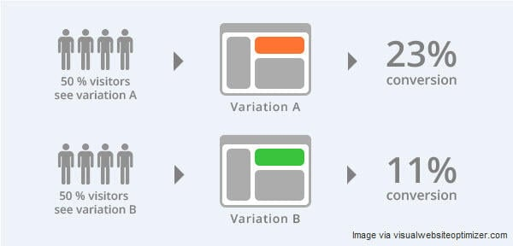

**Prove It**

Before you casually ask your designers and copywriters to create dozens of different buttons or calls to action by the end of the day, it’s crucial that you have a hypothesis you wish to test. After all, without at least some idea of the possible outcomes, A/B testing becomes A/B guessing. Similarly, without a hypothesis, discerning the true impact of design changes can be difficult and may lead to additional (and potentially unnecessary) testing, or missed opportunities that could have been identified had the test been performed with a specific objective in mind.

Just as scientists approach an experiment with a hypothesis, you should enter the multivariate testing phase with a clear idea of what you expect to see – or at the very least, some notion of what you think will happen.

Formulating a hypothesis doesn’t have to be complicated. You could A/B test whether subtle changes to the phrasing of a call to action results in more conversions, or whether a slightly different color palette reduces your bounce rate or improves your dwell time.

Whatever aspect of your site you decide to test, be sure that everyone involved in the project is aware of the core hypothesis long before any code, copy or assets are changed.

**Key Takeaway:** Before you begin your A/B test, know what you’re testing and why. Are you evaluating the impact of subtle changes to the copy of a call to action? Form length? Keyword placement? Make sure you have an idea of what effect changes to the variation will have before you start A/B split testing.

**RELATED:** If you’re looking for ways to increase conversions through calls to action, check out these call to action exakmples and why they’re so effective.

**Take a Granular Approach to A/B Testing**

One of the most common mistakes people make when performing A/B tests is comparing the results of landing page layouts that are too radically different from one another. Although it might be tempting to test the effectiveness of two completely different pages, doing so may not yield any actionable data. This is because the greater the differences between two versions of a page, the harder it is to determine which factors caused an improvement – or decline – in conversions.

Don’t be seduced by the idea that all variations in an A/B test have to be spectacular, show-stopping transformations. Even subtle changes can have a demonstrable effect, such as slightly reformatting a list of product features to persuade users to request more information, or phrasing a call to action differently to drive user engagement.

Even something as “harmless” as minor differences in punctuation can have a measurable impact on user behavior. Perry Marshall, marketing expert and author of “The Ultimate Guide to Google AdWords,” recalled an A/B test in which the CTR of two ads were evaluated. The only difference between the two? The inclusion of a single comma. Despite this seemingly irrelevant detail, the variant that featured the comma had a CTR of 4.40% – an improvement of .28 percentage points over the control.

However, that’s not to say that comparing user behavior on two very different versions of a page is completely without merit. In fact, doing so earlier in the testing phase can inform design decisions further down the pipeline. A/B testing best practices dictate that the greater the difference between two versions of a page, the earlier in the testing process these variations should be evaluated.

**Key Takeaway:** Test one element at a time so you’ll know for sure what change was responsible for the uptick in conversions. Once you’ve determined a winner, test another single change. Keep iterating until your conversion rate is maxed out.

**Test Early, Test Often**

Scientists rarely use the results of a single experiment to prove or disprove their hypotheses, and neither should you. To adhere to A/B testing best practices, you should evaluate the impact of one variable per test, but that doesn’t mean you’re restricted to performing just one test overall. That would be silly.

A/B testing should be a granular process. Although the results of the first test may not provide you with any real insight into how your users behave, they might allow you to design additional tests to gain greater understanding about what design choices have a measurable impact on conversions.

The sooner you begin A/B testing, the sooner you can eliminate ineffective design choices or business decisions based on assumptions. The more frequently you test certain aspects of your site, the more reliable the data will be, enabling you to focus on what really matters – the user.

**Key Takeaway:** Don’t put off A/B testing until the last minute. The sooner you get your hands on actual data, the sooner you can begin to incorporate changes based on what your users actually do,k. Test frequently to make sure that adjustments to your landing pages are improving conversions. When you’re building a landing page from scratch, keep the results of early tests in mind.

**Be Patient With Multivariate Tests**

A/B testing is an important tool in the marketing professional’s arsenal, but meaningful results probably won’t materialize overnight. When designing and performing A/B tests, be patient – ending a test prematurely might feel like saving time, but it could end up costing you money.

Economists and data scientists rely on a principle known as statistical significance to identify and interpret the patterns behind the numbers. Statistical significance lies at the very heart of A/B testing best practice, as without it, you run the risk of making business decisions based on bad data.

Statistical significance is the probability that an effect observed during an experiment or test is caused by changes made to a specific variable, as opposed to mere chance. To arrive at statistically significant results, marketers must have a sufficiently large data set to draw upon. Not only do larger volumes of data provide more accurate results, they also make it easier to identify standard deviations – typical variations from the average result that are not statistically significant. Unfortunately, it takes time to gather this data, even for sites with millions of unique monthly visitors.

If you’re tempted to cut a test short, step back for a moment. Take a deep breath. Grab a coffee. Do some yoga. Remember – patience is a virtue.

**Key Takeaway:** Resist the temptation to end a test early, even if you’re getting strong initial results. Let the test run its course, and give your users a chance to show you how they’re interacting with your landing pages, even when multivariate testing large user bases or high-traffic pages.

**Keep an Open Mind When A/B Testing**

Remember how we emphasized the importance of forming a hypothesis before starting the testing phase? Well, just because you have an idea of the outcome of an A/B test doesn’t mean it’s going to happen – or that your original idea was even accurate. That’s OK, though, we won’t make fun of you.

Many a savvy marketer has fallen prey to the idea that, regardless of what her results tell her, the original hypothesis was the only possible outcome. This insidious thought often surfaces when user data paints a very different picture than the one that project stakeholders were expecting. When presented with data that differs significantly from the original hypothesis, it can be tempting to dismiss the results or the methodologies of the test in favor of conventional knowledge or even previous experience. This mindset can spell certain doom for a project. After all, if you’re so confident in your assumptions, then why A/B test in the first place?

Chris Kostecki, a seasoned marketing and PPC professional, can certainly attest to the importance of keeping an open mind when A/B testing. While evaluating two versions of a landing page, Chris discovered that the variant – which featured more positional copy and was further away from the product ordering page – outperformed the control by a substantial margin.  Chris noted that although he was confident that the more streamlined page would result in more conversions, his A/B test results proved otherwise.

Remaining open to new ideas based on actual data and proven user behavior is essential to the success of a project. In addition, the longer the testing phase, and the more granular your approach, the more likely you are to discover new things about your customers and how they interact with your landing pages. This can lead to valuable insight into which changes will have the greatest impact on conversions. Let your results do the talking, and listen closely to what they tell you.

**Key Takeaway:** Users can be fickle, and trying to predict their behavior is risky. You’re not psychic, even if you do secretly have a deck of tarot cards at home. Use hard A/B test data to inform business decisions – no matter how much it surprises you. If you’re not convinced by the results of a test, run it again and compare the data.

**Maintain Momentum**

So, you’ve formulated your hypothesis, designed a series of rigorous tests, waited patiently for the precious data to trickle in, and carefully analyzed your results to arrive at a statistically significant, demonstrable conclusion – you’re done now, right? Wrong.

Successful A/B tests can not only help you increase conversions or improve user engagement, they can also form the basis of future tests. There’s no such thing as the perfect landing page, and things can always be improved. Even if everybody is satisfied with the results of an A/B test and the subsequent changes, the chances are pretty good that other landing pages can yield similarly actionable results. Depending on the nature of your site, you can either base future tests on the results of the first project, or apply A/B testing best practices to an entirely new set of business objectives.

**Key Takeaway:** Even highly optimized landing pages can be improved. Don’t rest on your laurels, even after an exhaustive series of tests. If everyone is happy with the results of the test for a specific page, choose another page to begin testing. Learn from your experiences during your initial tests to create more specific hypotheses, design more effective tests and zero in on areas of your other landing pages that could yield greater conversions.

**Choose Your Own Adventure**

No two scientific experiments are exactly alike, and this principle most definitely applies to A/B testing. Even if you’re only evaluating the impact of a single variable, there are dozens – if not hundreds – of external factors that will shape the process, influence your results and possibly cause you to start sobbing uncontrollably.

Take Brad Geddes, for example. Founder of PPC training platform Certified Knowledge, Brad recalled working with a client that had some seriously embarrassing landing pages. After much pleading and gnashing of teeth, Brad finally managed to convince his client to make some adjustments. The redesign was almost as bad as the original, but after being A/B tested, the new landing page resulted in an overall sitewide increase in profit of 76 % – not too shabby for a terrible landing page.

Don’t approach the testing phase too rigidly. Be specific when designing your tests, remain flexible when interpreting your data, and remember that tests don’t have to be perfect to provide valuable insights. Keep these points in mind, and soon, you’ll be a seasoned A/B testing pro – and no, you don’t have to wear a lab coat (but you can if you want to, it’s cool).

**Key Takeaway:** Every multivariate test is different, and you should remember this when approaching each and every landing page. Strategies that worked well in a previous test might not perform as effectively in another, even when adjusting similar elements. Even if two landing pages are similar, don’t make the mistake of assuming that the results of a previous test will apply to another page. Always rely on hard data, and don’t lose sleep over imperfect tests.

**Ultimate A/B Testing Guide for Data Science Interviews**

**Key Highlights**

* Understanding the fundamentals of A/B testing
* How to design effective A/B tests
* Analyzing A/B test results with precision
* Common pitfalls in A/B testing and how to avoid them
* Advanced A/B testing techniques for data science interviews

Before diving into the complexities of A/B testing, it's essential to grasp its basic principles. This section will cover the foundational concepts, terminology, and importance of A/B testing in data science. A/B testing, at its core, is a way to compare two versions of a single variable, typically by testing a subject's response to variant A against variant B, and determining which of the two variants is more effective.

**Understanding A/B Testing: Definition and Purpose**

A/B testing, also known as **split testing**, is a methodological way of comparing two versions of a webpage, email, or other marketing asset with just one varying element. For instance, you might test two different email subject lines to see which one leads to a higher open rate. The purpose of A/B testing is to enable data-driven decision-making rather than relying on assumptions. This is critical in **data science**, where empirical evidence drives optimization and innovation.

Consider the case of an e-commerce website that uses A/B testing to determine the most effective design for its checkout page. By creating two versions of the page (A and B) and randomly assigning visitors to each version, the site can measure which version leads to higher conversion rates. This approach ensures that changes are made based on data, not gut feelings.

**Navigating A/B Testing: Key Terminologies**

To effectively communicate and implement A/B testing strategies, it's crucial to understand the following terms:

* **Control group**: This is the group exposed to the original version of the variable being tested.
* **Treatment group**: This group experiences the new or changed version.
* **Significance level**: Often denoted as α, this represents the probability of rejecting the null hypothesis when it is true, typically set at 0.05.
* **P-value**: This measures the strength of evidence against the null hypothesis. A lower p-value indicates stronger evidence.

For example, in an A/B test aiming to increase newsletter sign-ups, the **control group** might receive the standard sign-up form, while the **treatment group** receives a version with simplified fields. Analyzing the **p-values** from the test results can help determine if the changes significantly impacted sign-ups, guiding data-driven decisions.

**The Critical Role of A/B Testing in Data Science**

In the realm of data science, A/B testing is invaluable for its ability to validate hypotheses and optimize outcomes systematically. It's a cornerstone for **optimizing user experience**, **enhancing marketing strategies**, and **improving product features**.

Take the example of a streaming service testing two algorithms for movie recommendations. By dividing users into two groups and applying a different algorithm to each, the service can measure which algorithm leads to longer viewing times and higher satisfaction. Such experiments are crucial for iterative improvement in products and services, underscoring the importance of A/B testing in data science for making evidence-based improvements.

**Designing Effective A/B Tests for 2024**

In the world of data science, A/B testing serves as a cornerstone for making informed, data-driven decisions. However, crafting an effective A/B test goes beyond merely dividing your dataset. This segment delves into the nuances of setting up your A/B test correctly, from selecting impactful variables to ensuring the validity and reliability of your test outcomes. Let's embark on a journey to design A/B tests that not only hold up to scientific scrutiny but also yield actionable insights.

**Choosing Variables and Control Groups for Impact**

**Selecting Variables and Control Groups:** The bedrock of any A/B test is its variables and control groups. The choice of variables significantly influences the test's outcome and applicability. For instance, if you're testing a new website layout to increase user engagement, your **variable** could be the layout design, and your **control group** would consist of users experiencing the current layout, while the **treatment group** experiences the new layout.

* **Practical Application:** Imagine an e-commerce platform planning to test a new checkout process. The variable is the checkout process itself. A random selection of users (treatment group) will navigate through the new checkout, while the control group sticks with the traditional process. The goal is to observe differences in conversion rates, providing clear insights into which process proves more effective.

By carefully selecting variables and control groups that align with your testing objectives, you ensure the production of meaningful, actionable results.

**Ensuring Test Validity and Eliminating Biases**

**Ensuring Test Validity:** The integrity of your A/B test hinges on its validity, which demands meticulous attention to detail to eliminate potential biases. For example, **time-based biases** can skew results if one group is tested during a sales peak while the other during a lull.

* **Technique to Overcome Bias:** Implementing **randomization** and **blocking** can significantly mitigate these biases. Randomization involves randomly assigning participants to control or treatment groups, ensuring each group is representative of the overall population. Blocking, on the other hand, means grouping participants based on characteristics (e.g., age, location) before randomization to ensure these variables don't unduly influence the outcome.

By adopting these techniques, you safeguard your A/B test against the common pitfalls that can compromise its reliability, paving the way for genuinely insightful conclusions.

**Calculating the Right Sample Size for Significance**

**Sample Size Calculation:** Determining the correct sample size is crucial for achieving statistical significance in your A/B tests. An inadequately sized sample can lead to inconclusive results, while an overly large sample may waste resources.

* **Practical Example:** Suppose you're testing two email campaign versions to see which yields a higher open rate. Using an online **sample size calculator** (Optimizely's Sample Size Calculator) can help. You'll need to input your baseline conversion rate, the minimum detectable effect (the smallest difference you care about detecting), and your desired statistical significance level.

This calculation ensures your test is adequately powered to detect meaningful differences between your control and treatment groups, enabling you to make informed decisions based on your A/B testing outcomes.

**Analyzing A/B Test Results: A Comprehensive Guide for 2024**

The analysis phase is a cornerstone in the realm of A/B testing, serving as the bridge that connects raw data with actionable insights. This segment delves into the methodologies and tools indispensable for scrutinizing test results, thereby empowering data scientists to deduce conclusions that are not only accurate but also pivotal for data-driven decision-making.

**Diving Deep into Statistical Methods for A/B Test Analysis**

**Understanding the Core**: At the heart of A/B test analysis lie statistical methods like the **t-test** and **chi-squared tests**, pivotal for discerning the significance of test results. For instance, the t-test, ideal for comparing means between two groups, can be applied in scenarios where you're testing the impact of a new website layout on user engagement. Here’s a simplified example:

from scipy.stats import ttest_ind

# sample data

control_group = [4, 5, 6, 7, 5]

treatment_group = [8, 7, 7, 6, 8]

# perform t-test

t_stat, p_value = ttest_ind(control_group, treatment_group)

print('T-statistic:', t_stat, '\nP-value:', p_value)

Copy

This snippet calculates the p-value to determine if the differences in averages are statistically significant. Similarly, the **chi-squared test** shines in analyzing categorical data, such as user click-through rates for different ad creatives.

**Practical Application**: Imagine you're testing two call-to-action buttons, 'Buy Now' vs. 'Learn More'. The chi-squared test helps ascertain which button leads to higher conversion rates, thus guiding strategic decisions.

Both methods are instrumental in validating hypotheses with precision, making them indispensable tools in the arsenal of a data scientist.

**Mastering the Art of Interpreting A/B Test Outcomes**

The interpretation of A/B test results transcends mere number crunching; it's about weaving a narrative that aligns with business objectives. **Understanding Statistical Significance**: A result's statistical significance, represented by the p-value, dictates whether observed differences are due to chance or a genuine effect of the treatment. For instance, a p-value less than 0.05 typically denotes significant differences worth noting.

**Making Data-Driven Decisions**: Beyond significance, it's crucial to consider effect size and confidence intervals to gauge the impact of your interventions. Suppose your new checkout process shortens the user journey by 30 seconds on average. While statistically significant, the real-world relevance depends on the context, such as the overall length of the checkout process.

**Example in Context**: Let's say an e-commerce platform tests two homepage designs. While both might improve user engagement, interpreting which design aligns better with long-term business goals (e.g., higher conversion rates vs. increased time on site) is key. This nuanced analysis ensures that data scientists contribute to strategic decision-making, leveraging their insights to champion data-driven culture within organizations.

**Leveraging Popular Tools for A/B Test Analysis**

In the digital age, an array of tools and software stand ready to streamline the A/B testing process. **Google Analytics**: A behemoth in the analytics world, Google Analytics offers robust capabilities for tracking and analyzing user behavior across websites. Its experiments feature allows for direct A/B test implementation and analysis, making it a go-to for many data scientists.

**Optimizely**: For those looking for a more specialized tool, Optimizely provides a platform focused on experimentation. With its intuitive interface, users can design tests, segment audiences, and glean insights with ease.

**Practical Use Cases**: Imagine leveraging Google Analytics to assess the performance of two landing pages. By setting up an experiment, you can directly compare metrics like bounce rate and conversion rate, informing which page drives better outcomes. Similarly, Optimizely can facilitate more complex tests, such as multivariate testing, allowing for deeper insights into how different elements interact to affect user behavior.

These tools not only simplify the analytical process but also enrich the quality of insights derived, enabling data scientists to make informed decisions swiftly.

**Common Pitfalls in A/B Testing and How to Avoid Them**

A/B testing, a cornerstone methodology in data science for comparing two versions of a web page, app feature, or anything else to determine which performs better, is not immune to missteps. Even the most experienced data scientists can encounter pitfalls that skew results and mislead decision-making processes. This section delves into common errors encountered during A/B testing and provides actionable advice to navigate around these obstacles, ensuring your testing process is both robust and reliable.

**Navigating the Challenges of Sampling Bias**

Sampling bias occurs when the participants in your A/B test are not representative of the broader population, leading to skewed results. For instance, if you're testing a new feature in an app but only select users who are highly active, you might falsely conclude the feature is widely popular. **Strategies to prevent sampling bias include:**

* **Randomization:** Ensure participants are randomly assigned to either the control or treatment group to mitigate pre-existing differences.
* **Stratification:** Divide your population into strata based on characteristics like age, location, or behavior, then sample equally from each stratum.
* **Continuous monitoring:** Regularly check your sample's characteristics against the broader population to catch and correct biases early.

Implementing these strategies can significantly reduce the risk of sampling bias, leading to more accurate and generalizable A/B test results.

**The Critical Role of Test Duration in A/B Testing**

Ignoring the duration of your A/B test can lead to misleading results. Running a test for too short a time may not capture the full effect of the change, while too long could mean external factors skew your data. For example, an e-commerce site running an A/B test on a checkout feature during the holiday shopping season might attribute changes in conversion rates to the test, rather than the seasonal shopping increase. **To ensure optimal test duration:**

* **Calculate minimum duration:** Use statistical tools to estimate the minimum time needed to achieve significant results.
* **Monitor external factors:** Keep an eye on events or trends that could influence your test outcomes and adjust your duration accordingly.
* **Avoid ending tests prematurely:** Resist the temptation to conclude tests early when results seem clear; significant trends can emerge given more time.

By carefully planning and adjusting the duration of your A/B tests, you can avoid common timing pitfalls and obtain more reliable insights.

**Leveraging Segmentation for Deeper Insights in A/B Testing**

Ignoring segmentation in A/B testing is a missed opportunity for deeper, more actionable insights. Segmentation involves dividing your test audience into groups based on shared characteristics and analyzing results within these segments. For instance, an online retailer might find that a new homepage layout increases overall conversion, but when segmenting by age, discovers it significantly decreases among users over 50. **To effectively use segmentation:**

* **Identify relevant segments:** Before the test, identify which customer characteristics (e.g., age, location, behavior) might influence their response to the variation.
* **Analyze results by segment:** Post-test, analyze outcomes not just in aggregate, but also for each predefined segment.
* **Apply learnings:** Use segmented insights to tailor strategies for different audience groups, maximizing the overall effectiveness of your changes.

Incorporating segmentation into your A/B testing strategy can unveil nuanced understandings of how different groups react to changes, guiding more informed decisions.

**Advanced A/B Testing Techniques for Data Science Interviews 2024**

In the competitive landscape of data science interviews, demonstrating a deep understanding of advanced A/B testing techniques can significantly elevate your standing. This section delves into sophisticated strategies such as multivariate testing, sequential testing, and the integration of machine learning with A/B testing, offering practical applications, examples, and insights to give you a distinct advantage.

**Multivariate Testing: Beyond A/B**

**Multivariate Testing (MVT)** expands on the concept of A/B testing by examining how multiple variables interact with each other. Unlike A/B testing, which compares two versions of a single variable, MVT can test multiple variations of several elements simultaneously to understand their collective effect on user behavior.

For instance, an e-commerce site looking to increase conversion rates might experiment with different combinations of product image sizes, call-to-action button colors, and header slogans. By analyzing the results, the site can discern not only which individual element is most effective but also how elements interact to produce the optimal user experience. Tools like Google Optimize facilitate the execution of such tests, providing actionable insights through easy-to-use interfaces.

Practical applications of MVT include optimizing web page layouts, email marketing campaigns, and app interfaces, ensuring that all elements work harmoniously to achieve business goals. The key to successful MVT is a structured approach: define clear objectives, select relevant elements for testing, and use robust statistical methods to analyze outcomes.

**Sequential Testing: Making Dynamic Decisions**

**Sequential Testing** is a dynamic approach to A/B testing that allows for continuous monitoring and decision-making as data is collected. Unlike traditional methods, where the sample size is fixed in advance, sequential testing provides the flexibility to make early conclusions or adjust hypotheses based on interim results.

A practical example of sequential testing could be in online advertising. Imagine a scenario where two ad creatives are tested against each other for engagement rates. Instead of waiting for the campaign to end, the marketer can assess performance at predetermined intervals. If one creative significantly outperforms the other early on, resources can be reallocated to maximize ROI, or the test can be stopped altogether to prevent further investment in a less effective ad.

This technique reduces the time and resources needed to reach conclusive results. However, it requires careful planning to avoid increased error rates. Statistical tools like Sequential Analysis provide frameworks to ensure the reliability of these adaptive tests, making them invaluable for fast-paced environments where agility is key.

**Leveraging Machine Learning in A/B Testing**

**Machine Learning (ML)** in A/B testing represents the frontier of data-driven decision-making, offering the ability to not only automate test processes but also uncover deeper insights into consumer behavior. By applying ML algorithms, data scientists can predict outcomes, personalize experiences, and optimize tests in real-time.

A compelling application of ML in A/B testing is in **personalization**. For example, Netflix uses advanced algorithms to personalize content recommendations for its users. By conducting A/B tests on these algorithms, Netflix can continually refine its recommendations to enhance user engagement and satisfaction.

Another example is the use of predictive models to determine the optimal timing for email campaigns. By analyzing past engagement data, ML algorithms can predict when recipients are most likely to open an email, enabling marketers to tailor their A/B tests around these peak times for maximum impact.

Tools like Optimizely integrate ML capabilities, making it easier for companies to implement these advanced techniques. The key to success lies in the proper selection of algorithms and a deep understanding of the underlying business context, ensuring that ML enhances rather than complicates the A/B testing process.

**Conclusion**

A/B testing is an indispensable skill in the arsenal of a data scientist. This guide has walked you through the fundamentals, design principles, analysis techniques, common pitfalls, and advanced strategies of A/B testing. Armed with this knowledge, you're now better prepared to tackle A/B testing questions in your next data science interview. Remember, the key to mastering A/B testing lies in continuous learning and practice. Best of luck in your data science journey!

**FAQ**

**Q: What is A/B testing and why is it important for a data scientist candidate?**

A: A/B testing, also known as split testing, is a method of comparing two versions of a webpage or app against each other to determine which one performs better. For a data scientist candidate, understanding A/B testing is crucial because it is a fundamental tool for data-driven decision-making, allowing for the optimization of outcomes based on empirical evidence.

**Q: How can I design an effective A/B test?**

A: Designing an effective A/B test involves several key steps: clearly defining the goal of the test, selecting variables that will be tested, ensuring you have a control group and a treatment group, and calculating the correct sample size to ensure statistical significance. Additionally, it's important to eliminate biases and ensure the reliability of your test outcomes.

**Q: What are some common pitfalls in A/B testing and how can I avoid them?**

A: Common pitfalls include sampling bias, overlooking test duration, and ignoring segmentation. To avoid these, ensure your sample is representative of the population, run your test for an adequate duration to capture meaningful data, and segment your data to gain deeper insights and more nuanced conclusions.

**Q: What advanced A/B testing techniques should I be aware of for a data science interview?**

A: For a data science interview, be prepared to discuss advanced techniques such as multivariate testing (comparing more than two variables simultaneously), sequential testing (analyzing data as it is collected), and the application of machine learning algorithms to automate and optimize A/B testing processes.

**Q: Can you provide a cheat sheet for key terminologies in A/B testing?**

A: Certainly! **Control Group:** The group exposed to the original version. **Treatment Group:** The group exposed to the new version. **Significance Level:** The probability of rejecting the null hypothesis when it is true. **P-value:** The probability of observing test results at least as extreme as the results actually observed, under the assumption that the null hypothesis is correct.

**Q: How important is sample size calculation in A/B testing?**

A: Calculating the correct sample size is crucial in A/B testing because it ensures that the test has enough power to detect a meaningful difference between the control and treatment groups if one exists. An incorrect sample size can lead to inconclusive or misleading results, affecting the decision-making process.

**Q: How can A/B testing contribute to a successful data science interview?**

A: A/B testing can significantly contribute to a successful data science interview by showcasing your ability to use data-driven methods to make empirical decisions, optimize outcomes, and solve complex problems. Demonstrating a deep understanding of A/B testing principles, methodologies, and common pitfalls can set you apart as a candidate.

**What is A/B Testing in Data Science?**

Statistics help digital marketers understand how successful their ad campaigns, marketing events, and websites are. Testing yields those necessary statistics, and many different forms of testing are available. Today, we’re answering the question, “What is A/B testing?”

This article focuses on A/B testing in data science, including defining the term, explaining its importance, showing how it works and how to conduct it, when to use it, and other valuable tidbits. We’ll round things out by discussing the common mistakes associated with A/B testing, real-world applications, what tools data scientists use to conduct A/B testing, and a data science bootcamp professionals can take to boost their careers.

Let’s get the ball rolling with a definition. What is A/B testing in data science?

What is A/B Testing in Data Science?

A/B testing, also known as “split testing,” is a method employed extensively in data science. It allows data scientists to generate accurate, evidence-based decisions using the insights gained from testing two different variables. A/B testing is an experiment on two variants using a given metric to see which performs better.

A/B testing divides traffic into two groups and serves one group, the A/B version, and the other, the control. It helps data scientists determine what works and doesn’t work for the organization and enables them to evaluate the impact of different versions on conversion and response rates.

**Also Read: What is Exploratory Data Analysis? Types, Tools, Importance, etc.**

Why A/B Testing is Important

A/B testing in data science is critical to data-driven decision-making because it helps data scientists eliminate guesswork by comparing two versions of a marketing campaign, web page, or product feature to see which performs better.

Additionally, A/B testing in data science helps marketers better understand user behavior, which is vital in user experience (UX) design, conversion rate optimization, and similar fields.

A data scientist or marketing professional who runs an A/B test can isolate the variables directly affecting the outcome. This process lets data scientists identify whether the changes made had a positive, negative, or null impact on user behavior. The insights gleaned from A/B testing can then be used to make better, more informed decisions and optimize the various aspects of a service or product.

A/B testing is a valuable part of data science and marketing efforts because our world increasingly relies on the ever-growing volumes of data generated daily. Numbers must back up business decisions, and A/B testing helps fill that gap.

When to Use A/B Testing

Since every form of testing has strong points and places where it does the most good, when should we use A/B testing? A/B testing excels in situations like testing incremental changes. Incremental changes include UX adjustments, new features, page load times, and ranking. Here, researchers can compare outcomes before and after the modifications to ascertain whether the changes have the desired effect.

On the other hand, A/B testing only functions effectively when used to test significant changes, such as new branding, new products, or a whole new user experience.

Now, let’s look at how to perform an A/B test.

How to Conduct an A/B Test

There are three stages in conducting A/B tests.

Generate Your Hypothesis

Before running your tests, you must generate your hypothesis. A hypothesis is an unproven assumption about how the natural world functions. Alternatively, it’s a reasonable prediction about something in the immediate environment that can be verifiable via observation or experimentation. You must generate a null hypothesis and an alternative hypothesis.

* **Null hypothesis.** A null hypothesis declares that sample observations result completely from chance. In the context of an A/B test, the null hypothesis states that there is no difference between the control and variant groups.
* **Alternative hypothesis.** The alternative hypothesis states that a non-random cause influences sample observations. In the context of an A/B test, the alternative hypothesis says there’s a difference between the control and variant groups.

Regardless of the hypothesis, you should follow the PICOT rules when formulating it.

* **Population.** This is the group of people participating in the experiment.
* **Intervention.** This is the new variant in the study.
* **Comparison.** This refers to what reference group you are using to compare against your intervention.
* **Outcome.** The outcome signifies what result you plan on measuring.
* **Time.** Time refers to the duration of the experience, including when and for how long the data will be collected.

Create the Control and Test Groups

Once you have developed your hypotheses, you need to create your control and test (variant) groups. In this step, remember these two vital concepts: random sampling and sample size.

* **Random Sampling.**In random sampling, each sample in the population has an equal chance of getting selected. Random sampling is crucial in hypothesis testing because it removes sampling bias; it’s essential to eliminate bias because the A/B test results must represent the whole population rather than the sample itself.
* **Sample Size.**Before conducting the test, determining the minimum sample size for the A/B test is essential. This way, you eliminate under-coverage bias or bias from sampling too few observations.

Run the A/B Tests and Gather the Results, Either Rejecting or Keeping the Null Hypothesis

After you conduct the experiment and collect the data, determine if the difference between the control and variant groups is statistically significant. How do you do this? By following these three simple steps:

* Set your alpha, which is the probability of making a type 1 error. In most cases, the alpha is set at 5% or 0.05.
* Determine the probability value (p-value). Start by calculating the t-statistic using the formula below.
* Finally, compare the p-value to the alpha. Don’t reject the null if the p-value is greater than the alpha.

Alternately, some sources posit that there are five stages associated with A/B tests:

* Run the experiment
* Measure the results
* Determine the conversion to improve
* Hypothesize changes
* Identify the variables and create variations

**Also Read: What is Data Wrangling? Importance, Tools, and More**

The Common Mistakes to Avoid in A/B Testing

There are a few significant mistakes that data science experts risk committing. They are:

* **Invalid Hypothesis.**The entire experiment is predicated solely on the hypothesis. What needs to be changed, what justifies these changes, and what are the desired results? The chance of the test succeeding diminishes if you start with an incorrect hypothesis.
* **Testing too many components simultaneously.**Try to run as few tests as possible at once. Running too many tests simultaneously might be challenging to discern which aspect contributed to success or failure. Therefore, it’s vital to prioritize tests for effective A/B testing.
* **Ignoring Statistical Significance.**Your opinion of the test doesn’t matter. Let the test run its full course, whether it succeeds or fails, so that it acquires statistical significance.
* **Not taking external factors into account.**Tests should be run during comparable times so that you may obtain significant findings. For example, comparing website hits on high-traffic days to days with the lowest traffic because of external factors such as sales or holidays is unfair and will yield a flawed conclusion.

Real-World Applications of A/B Testing

So, how does A/B testing work in the real world? Check out this pair of examples and see how A/B testing in data science contributes to the digital economy.

User Experience Design

A/B testing is used in user experience (UX) design to identify obstacles that prevent customers from optimally interacting with a website, service, or product. It helps UX designers determine what adjustments are required on the website or application to give consumers a seamless and delightful user experience.  
  
For example, UX designers could run an A/B test for two different shopping cart/checkout process versions on an e-commerce site and see which one results in a more complete, effortless purchase. So, A/B testing lets designers make better data-driven design decisions.

Marketing Analytics

A/B testing is widely used in marketing analytics to optimize marketing efforts. It lets marketers test different versions of their campaigns and messages and discern which resonates the most with their prospective customers.

Only after conducting extensive A/B testing can marketers accurately decide which changes are worth the effort.

From landing page designs to e-mail marketing campaigns, A/B testing plays a significant part in today’s digital marketing strategies. A/B testing minimizes risk and increases the chances of a successful marketing campaign.

Tools Used for A/B Testing in Data Science

A/B testing in data science has many tools to make the job easier. Here’s a list of 13 popular A/B testing tools. Choosing the ideal A/B testing tool largely depends on your unique needs. When you’re ready to shop for A/B testing tools, consider crucial factors such as pricing, ease of use, and analysis level.

Ensure the tool you choose supports your marketing goals, including conversion rate optimization, boosting user engagement, or even reducing churn rate. Picking the right testing tool will play a significant role in conducting a successful A/B test and leveraging data for organizational success.

* **AB Tasty**
* **Adobe Target**
  + **Convert**
* **Dynamic Yield**
* **Google Optimize**
* **Kameleoon**
* **LaunchDarkly**
* **Omniconvert**
  + **Optimizely**
* **Oracle Maxymiser**
* **SiteSpect**
* **Statsig**
* **VWO**

**A/B testing best practices: How to create experiments that convert**

Like any tool, the efficacy of A/B testing lies in its correct usage.

It's not as simple as changing the color of a button on your landing page or tweaking the subject line of an email. The process involves careful planning, execution, and analysis.

In this blog post, we will delve into the best practices for A/B testing. We'll explore how to formulate a strong hypothesis, select the right variables to test, ensure your sample size is representative, and accurately interpret the results.

We'll also discuss the common pitfalls to avoid and how to ensure your tests contribute to a better understanding of your audience and their preferences.

By the end of this post, you'll be equipped with the knowledge to create A/B testing experiments that not only convert but also provide valuable insights to fuel your future marketing strategies.

**1. Start with a hypothesis**

A hypothesis, in the realm of A/B testing, is an educated guess or assumption about what you believe could improve the performance of your webpage, email, or other marketing assets. It's a prediction about the relationship between two variables: the element you are changing (independent variable) and the outcome you want to influence (dependent variable).For example, let's say you have noticed that the conversion rate on your product page is lower than industry standards. You might hypothesize that changing the color of the "Add to Cart" button from grey (which might blend with the background) to a bright and bold color like red (which stands out) will make it more noticeable and therefore increase click-throughs and conversions.

In this case, your hypothesis might be stated as: "If we change the 'Add to Cart' button color to red, then the conversion rate will increase because the button will be more noticeable."

Starting with a hypothesis is crucial for a few reasons:

* **Direction:** It gives your test a clear direction and purpose. Knowing what you're testing and why helps you focus on achieving specific goals.
* **Measurement:** It enables you to measure the impact of your changes. By defining what you expect to happen, you can better assess whether the change had the desired effect.
* **Insight:** It provides valuable insights into user behavior. Even if your hypothesis turns out to be incorrect, you still gain useful information about what doesn't work, helping you refine future tests.
* **Efficiency:** It saves time and resources. By focusing on testing elements based on a well-thought-out hypothesis, you avoid random testing, which may not yield meaningful results.

Remember, a good hypothesis is specific, testable, and based on research and data. It's not just a random guess but a well-informed assumption that guides your A/B testing towards meaningful improvements.

**2. Test one element at a time**

The importance of testing one element at a time during A/B testing cannot be stressed enough.

This approach, also known as "isolated testing," is crucial to identify what is driving changes in your performance metrics accurately.

Let's consider an example. Suppose you decide to test a new headline and a different call-to-action (CTA) button color simultaneously on your landing page. If you notice an improvement in conversion rates, it would be impossible to discern whether the change was due to the new headline, the altered CTA color, or a combination of both.

By testing multiple elements at once, you muddy the waters and make it difficult to draw clear conclusions from your data. The results become ambiguous, and you lose the opportunity to gain precise insights about the impact of each individual change.

On the other hand, if you test one element at a time - first the headline, then the CTA color - you can clearly attribute any change in performance to the specific element you modified. This provides more actionable insights that you can use to optimize further.

To implement this approach effectively:

* **Prioritize Your Tests:** Not all elements have the same impact on conversions. Prioritize testing those elements that are likely to have a significant effect on user behavior, such as headlines, CTAs, or images.
* **Plan Your Tests:** Create a testing roadmap where you outline what elements you will test and in what order. This helps you stay organized and ensures you don’t skip important elements.
* **Analyze and Iterate:** After each test, analyze the results, implement the winning version, and then move on to the next element. Remember, CRO is a continuous process of testing, learning, and improving.

**3. Use a representative sample size**

Having a representative sample size is another critical component of successful A/B testing. It's the key to obtaining reliable and statistically significant results.

In A/B testing, your sample size refers to the number of users who are exposed to each version of your test. If your sample size is too small, your results may be influenced by random chance rather than reflecting genuine user behavior or preferences. On the other hand, if you have a large enough sample size, you're more likely to capture a true representation of your audience's responses.

Let's illustrate this with an example: Imagine you're testing two headlines on your website, and you only expose each version to 10 visitors. Even if one headline outperforms the other, with such a small sample size, it's hard to confidently say that the result wasn't due to chance. However, if you tested each headline with 1,000 visitors, your results would be much more reliable.

Here are some tips to ensure a representative sample size in your A/B tests:

* **Calculate the required sample size before starting the test.** There are many online tools and calculators available that can help you determine the optimal sample size based on your website's traffic, expected conversion rates, and desired confidence level.
* **Run the test until you reach your desired sample size.** Cutting a test short could lead to inaccurate results. Be patient and allow the test to run until you've reached your pre-determined sample size.
* **Ensure your sample is diverse.** To get a true representation of your audience, make sure your sample includes a mix of different types of users (new visitors, returning visitors, users from different locations, etc.).

Remember, the goal of A/B testing is not just to find out which version is better, but to gain insights that you can confidently apply to optimize your marketing strategy.

**4. Allow sufficient run time**

The statistical significance and reliability of test results greatly depend on not just the sample size, but also on the duration of the test.

If you stop a test too early, you risk making decisions based on incomplete or misleading data. For instance, if you launch a test and see a dramatic increase in conversions within the first few hours or days, it might be tempting to declare a winner and implement changes immediately. However, such a hasty decision can be problematic due to several reasons:

* **Initial Fluctuations:** It's common to see large swings in performance when a test first starts. These often settle down over time, and early results may not reflect the true effect of the change.
* **Variability in User Behavior:** User behavior can vary significantly depending on the day of the week, time of the day, or even season of the year. Running a test for a short period may only capture a subset of your audience's behavior.
* **Statistical Significance:** The longer a test runs (assuming it's receiving enough traffic), the more confident you can be in the results. Short tests are more susceptible to random variations that can lead to false positives or negatives.

As a rule of thumb, it's recommended to run a test for at least one full business cycle (usually a week) to account for daily and weekly variations in user behavior. However, the exact duration can depend on factors like your website's traffic, baseline conversion rate, and the minimum detectable effect.

**5. Analyze and interpret the results correctly**

Analyzing the test results is not just about identifying the winning variant, but also understanding why one version performed better than the other and how these insights can be applied to future optimization efforts.

Surface-level data such as conversion rates and click-through rates can provide a quick overview of which variant performed better. However, deeper analysis is required to fully understand the implications of your test results. Here's how you can go about it:

* **Segment Your Data:** Break down your results by different user segments such as new vs. returning visitors, different traffic sources, device types, geographic locations, etc. This can reveal valuable insights and help you understand if certain changes work better for specific segments of your audience.
* **Analyze Secondary Metrics:** Don't just focus on your primary conversion goal. Look at how the test affected secondary metrics like time on page, bounce rate, pages per visit, etc. This can provide a more holistic view of user behavior and the overall impact of the test.
* **Look for Statistical Significance:** Ensure that your results are statistically significant. This means that the difference in performance between the two versions is not due to random chance. Tools like a p-value calculator can help with this.
* **Draw Conclusions and Hypotheses:** Based on your analysis, draw conclusions about why one version outperformed the other. Use these insights to form new hypotheses for future tests.
* **Document Everything:** Keep a record of all your tests, results, and learnings. This will help you build a knowledge base and avoid repeating unsuccessful tests in the future.

Remember, the goal of A/B testing is not just to get a lift in conversions and engagement, but also to gain a deeper understanding of your users and their behavior. By analyzing and interpreting your results correctly, you can ensure that your testing efforts contribute to long-term, sustainable growth.

**6. Iterate and improve**

The goal of CRO is not just to find a "winning" version and stop there, but to continuously learn about your users, iterate on your designs, and improve your website's performance over time.

A/B testing is essentially a scientific method applied to your website or app. You formulate a hypothesis, design an experiment (the A/B test), collect data, and then analyze the results. But the process doesn't end there. Based on what you've learned, you then create a new hypothesis and start the process over again.

Let's say, for example, you run an A/B test on your product page, changing the color of the "Add to Cart" button from blue to green. The green button results in a 10% increase in clicks. Great! But don't stop there. Now you might ask: "Would a different shade of green result in even more clicks?" or "What if we make the button larger?" or "What if we change the text on the button?" Each of these questions can form the basis of a new A/B test.

Here are some tips for iterating and improving through A/B testing:

* **Be Methodical:** Don't change too many things at once. If you do, you won't know which change caused the difference in performance. Stick to one variable at a time whenever possible.
* **Keep Learning:** Even "failed" tests—those where there was no significant difference between versions or where the original version outperformed the new one—are valuable. They give you insights into what doesn't work for your audience.
* **Prioritize Your Tests:** Not all changes are created equal. Prioritize tests based on potential impact and ease of implementation.
* **Patience and Persistence:** Optimization is a long-term process. Don't be discouraged by tests that don't result in a big lift. Even small, incremental improvements can add up over time.

To sum up, A/B testing is about much more than finding a "winning" version. It's a tool for continuous learning and improvement. Always keep testing, tweaking, and learning from your findings.

**7. Document everything**

Documentation is a crucial part of the optimization process. It might seem like an administrative task, but it serves several important purposes in your CRO strategy.

By documenting everything, you create a historical record of your tests, which can be extremely valuable for several reasons:

* **Learning from Past Tests:** By documenting the results of each test, you can see what worked and what didn't. This can help you avoid repeating the same mistakes and also build upon successful strategies.
* **Understanding Your Audience:** Over time, your testing documents will provide a composite picture of your audience's preferences and behavior. For instance, you may notice that certain types of headlines consistently perform better, or that your audience responds well to specific calls to action. These insights can guide future tests and broader marketing strategies.
* **Informing Future Tests:** When planning new tests, it's helpful to look back at previous ones for ideas and insights. You may find patterns that suggest new hypotheses to test.
* **Maintaining Consistency:** Documenting your tests also helps ensure consistency in how you conduct and evaluate them. For example, you can note down the statistical significance level you're using, how you segment your data, etc. This makes it easier to compare results across different tests.
* **Communicating Results:** If you're part of a larger team, documentation can help you communicate your findings to other stakeholders. It provides a clear, objective record of what was tested, the results, and any changes that were implemented as a result.

In terms of what to document, you should include the hypothesis of the test, the elements that were changed, the duration of the test, the results (including statistical significance), and any observations or conclusions. Tools like Google Sheets or project management software can be used to keep track of all this information

**The Bottom Line**

The true power of A/B testing lies not just in executing tests but in adopting a systematic, data-driven approach to understanding your users and their behavior.

From formulating a strong hypothesis, designing effective experiments, correctly analyzing and interpreting results, to continuously iterating based on findings, each step plays a crucial role in the success of your A/B tests. Remember, it's not just about finding a winning variant, but about gaining insights that can lead to ongoing improvements in your conversion rate.

Documenting your tests and results is equally important. It helps build a knowledge base, informs future tests, and provides a clearer understanding of your audience over time.

A/B testing isn't a one-time effort but a journey of continuous learning and improvement. With these best practices in mind, you're well-equipped to create experiments that convert, ultimately boosting your business's bottom line.  
**************************************************************

**A guide to passing the A/B test interview question in tech companies**

Hey all,

I'm a Sr. Analytics Data Scientist at a large tech firm (not FAANG) and I conduct about ~3 interviews per week. I wanted to share my advice on how to pass A/B test interview questions as this is an area I commonly see candidates get dinged. Hope it helps.

Product analytics and data scientist interviews at tech companies often include an A/B testing component. Here is my framework on how to answer A/B testing interview questions. Please note that this is not necessarily a guide to design a good A/B test. Rather, it is a guide to help you convince an interviewer that you know how to design A/B tests.

**A/B Test Interview Framework**

Imagine during the interview that you get asked “Walk me through how you would A/B test this new feature?”. This framework will help you pass these types of questions.

**Phase 1: Set the context for the experiment. Why do we want to AB test, what is our goal, what do we want to measure?**

1. The first step is to clarify the purpose and value of the experiment with the interviewer. Is it even worth running an A/B test? Interviewers want to know that the candidate can tie experiments to business goals.
2. Specify what exactly is the treatment, and what hypothesis are we testing? Too often I see candidates fail to specify what the treatment is, and what is the hypothesis that they want to test. It’s important to spell this out for your interviewer.
3. After specifying the treatment and the hypothesis, you need to define the metrics that you will track and measure.
   * Success metrics: Identify at least 2-3 candidate success metrics. Then narrow it down to one and propose it to the interviewer to get their thoughts.
   * Guardrail metrics: Guardrail metrics are metrics that you do not want to harm. You don’t necessarily want to improve them, but you definitely don’t want to harm them. Come up with 2-4 of these.
   * Tracking metrics: Tracking metrics help explain the movement in the success metrics. Come up with 1-4 of these.

**Phase 2: How do we design the experiment to measure what we want to measure?**

1. Now that you have your treatment, hypothesis, and metrics, the next step is to determine the unit of randomization for the experiment, and when each unit will enter the experiment. You should pick a unit of randomization such that you can measure success your metrics, avoid interference and network effects, and consider user experience.
   * As a simple example, let’s say you want to test a treatment that changes the color of the checkout button on an ecommerce website from blue to green. How would you randomize this? You could randomize at the user level and say that every person that visits your website will be randomized into the treatment or control group. Another way would be to randomize at the session level, or even at the checkout page level.
   * When each unit will enter the experiment is also important. Using the example above, you could have a person enter the experiment as soon as they visit the website. However, many users will not get all the way to the checkout page so you will end up with a lot of users who never even got a chance to see your treatment, which will dilute your experiment. In this case, it might make sense to have a person enter the experiment once they reach the checkout page. You want to choose your unit of randomization and when they will enter the experiment such that you have minimal dilution. In a perfect world, every unit would have the chance to be exposed to your treatment.
2. Next, you need to determine which statistical test(s) you will use to analyze the results. Is a simple t-test sufficient, or do you need quasi-experimental techniques like difference in differences? Do you require heteroskedastic robust standard errors or clustered standard errors?
   * The t-test and z-test of proportions are two of the most common tests.
3. The next step is to conduct a power analysis to determine the number of observations required and how long to run the experiment. You can either state that you would conduct a power analysis using an alpha of 0.05 and power of 80%, or ask the interviewer if the company has standards you should use.
   * I’m not going to go into how to calculate power here, but know that in any AB  test interview question, you will have to mention power. For some companies, and in junior roles, just mentioning this will be good enough. Other companies, especially for more senior roles, might ask you more specifics about how to calculate power.
4. Final considerations for the experiment design:
   * Are you testing multiple metrics? If so, account for that in your analysis. A really common academic answer is the Bonferonni correction. I've never seen anyone use it in real life though, because it is too conservative. A more common way is to control the False Discovery Rate. You can google this. Alternatively, the book [Trustworthy Online Controlled Experiments](https://amzn.to/4dzXyZP) by Ron Kohavi discusses how to do this (note: this is an affiliate link).
   * Do any stakeholders need to be informed about the experiment?
   * Are there any novelty effects or change aversion that could impact interpretation?
5. If your unit of randomization is larger than your analysis unit, you may need to adjust how you calculate your standard errors.
6. You might be thinking “why would I need to use difference-in-difference in an AB test”? In my experience, this is common when doing a geography based randomization on a relatively small sample size. Let’s say that you want to randomize by city in the state of California. It’s likely that even though you are randomizing which cities are in the treatment and control groups, that your two groups will have pre-existing biases. A common solution is to use difference-in-difference. I’m not saying this is right or wrong, but it’s a common solution that I have seen in tech companies.

**Phase 3:** **The experiment is over. Now what?**

1. After you “run” the A/B test, you now have some data. Consider what recommendations you can make from them. What insights can you derive to take actionable steps for the business? Speaking to this will earn you brownie points with the interviewer.
   * For example, can you think of some useful ways to segment your experiment data to determine whether there were heterogeneous treatment effects?

**Common follow-up questions, or “gotchas”**

These are common questions that interviewers will ask to see if you really understand A/B testing.

* Let’s say that you are mid-way through running your A/B test and the performance starts to get worse. It had a strong start but now your success metric is degrading. Why do you think this could be?
  + A common answer is novelty effect
* Let’s say that your AB test is concluded and your chosen p-value cutoff is 0.05. However, your success metric has a p-value of 0.06. What do you do?
  + Some options are: Extend the experiment. Run the experiment again.
  + You can also say that you would discuss the risk of a false positive with your business stakeholders. It may be that the treatment doesn’t have much downside, so the company is OK with rolling out the feature, even if there is no true improvement. However, this is a discussion that needs to be had with all relevant stakeholders and as a data scientist or product analyst, you need to help quantify the risk of rolling out a false positive treatment.
* Your success metric was stat sig positive, but one of your guardrail metrics was harmed. What do you do?
  + Investigate the cause of the guardrail metric dropping. Once the cause is identified, work with the product manager or business stakeholders to update the treatment such that hopefully the guardrail will not be harmed, and run the experiment again.
  + Alternatively, see if there is a segment of the population where the guardrail metric was not harmed. Release the treatment to only this population segment.

*************************************************************************

**13 AB Testing Best Practices**

A/B testing is a critical tool for optimizing digital experiences. It allows you to directly compare two versions of a page, ad, email, or other component by showing one variation (version A) to some visitors and a different variation (version B) to others.

By tracking key metrics like conversions, clickthrough rate, or time on page for each variant, you can determine which version performs better.

Running A/B tests is essential for companies today because it enables data-driven improvement of customer experiences. Rather than guessing what will optimize conversions or engagement, A/B testing eliminates conjecture by putting your ideas to the test.

The data reveals how changes impact real customer behavior. This allows you to iterate based on evidence, increasing key performance indicators over time.

With the fierce competition online, A/B testing is no longer optional – it’s necessary to stand out, remove friction, and deliver the experiences customers want most.

In this article, we’ll dive deep into AB testing best practices across several key sections.

Let’s get start

**A/B testing best practices during the planning stage**

**Clearly define goals and hypotheses upfront**

Begin by clearly articulating your goals for the test. Go beyond vague notions of “increasing conversions” and define exactly which metric you want to improve. State the baseline performance and your target numeric increase. For example, “Increase landing page conversion rate from 2.5% to 3.5%.” Quantifiable goals clarify what success looks like.

With clear goals set, formulate hypothesis statements about which changes will drive improvement. Hypotheses connect design tweaks or content changes to the desired lift in your goal metric. For instance, “Removing the lead magnet popup on the blog homepage will increase time on page by 15%.” This ties the design change of removing an element to the anticipated impact on site engagement.

Craft multiple hypotheses about different variables that may influence your goals. Prioritize the hypotheses with the largest potential impact for testing. For each priority hypothesis, outline what variations you will show to test it. These become the A and B versions of your test.

Document all goals, hypotheses and planned variants before beginning test setup. This upfront investment in planning is time well spent to shape tests that produce actionable insights. Structure tests around clear hypotheses and metrics to learn what really moves the needle for your goals.

**– Prioritize elements with high traffic or conversion potential**

Prioritize elements with high traffic or conversion potential. Focus your testing on pages that get the most visits, like your category pages or product pages. These high-traffic pages have the most opportunity to influence key metrics.

Analyze your analytics to identify top entry and exit pages. Sort pages by traffic volume and bounce rates. Pages with high entrances and exits are priorities—test changes to grab attention or reduce departures. For example, refresh a stale homepage visitors exit quickly from.

Map the user journey and find friction. Study your conversion funnel and workflows. Where do customers commonly encounter speed bumps or extra steps? Prioritize optimizing these pain points. For instance, if checkout abandonment is high, test ways to simplify the process. Smoothing rough edges fuels conversions.

Define your primary success metric like conversion rate or time on site. Then analyze which pages have the biggest influence on this goal. Test pages correlated with your KPI first. Start with quick wins that build momentum.

Leverage internal search data. See which on-site content brings traffic but has low engagement. Refreshing these pages can better attract and retain visitors.

Maximize impact by testing pages with high visibility and potential first. Traffic volume, bounce rates, funnel friction, correlations—use data to inform what you test.

**– Limit scope to isolate key variables and avoid too many changes**

Only test one or two variables at a time. Comparing multiple changes in A/B tests muddles insights about what impacted metrics. For example, test button color OR test button text, but don’t test both together.

Isolate key variables like headlines, copy, or calls-to-action. Don’t make dramatic page-wide changes that disrupt layout or information architecture. For instance, keep page sections the same and solely test introducing/removing a sidebar widget.

Don’t drastically redesign page layout or content flow. Radical changes make it impossible to connect results to specific elements. Users may bounce simply because the experience is too disrupted. Keep layout, imagery, and content structure identical between A/B versions.

Follow the principle of least change. Only modify what’s essential to test your hypothesis. If you want to test how a longer homepage headline performs, every other element should be identical between versions. Don’t simultaneously increase body text size. Introducing too many variables pollutes data.

By limiting test variables and scope, you gain insights about how isolated changes impact metrics. This disciplined approach provides clear learning to optimize digital experiences.

**– Determine appropriate sample size and test duration**

Use power calculators to estimate minimum sample size needed. Power calculators factor in your traffic numbers, baseline conversion rate, and desired minimum detectable effect. Plugging in values provides the minimum visitors required per variation.

Set test duration for at least 1-2 weeks. Shorter tests may not achieve statistical significance. Allot time to allow your minimum sample size to be exposed to the test variations. Don’t end tests prematurely.

Avoid small samples prone to random variance. For example, if 100 visitors per variation is needed but the test is stopped at 50, results are unreliable. Stick to power calculator guidance.

Account for seasonality in traffic. Tests may need to run longer during slow periods to reach sample sizes. Plan duration based on low-traffic projections.

Build in buffer time for analysis. End tests on Fridays to allow time to analyze results before the next week begins. Don’t stop tests abruptly without assessing data.

Determine significance thresholds like 95%+ confidence level and 0.5%+ difference between variants. Test until variations achieve your targets.

Properly setting test length and minimum sample size provides statistically significant results upon which to base optimization decisions. Take the guesswork out with power calculators.

**AB testing best practices during the implementation phase**

**– Use proper technical set-up of identical pages except for one variable**

A critical foundation of effective A/B testing is constructing technically identical test variations that isolate the variable being analyzed.

Start by duplicating the target page – for example, making a copy of your product page called product-variant. The original page and the variant should be completely identical in layout, imagery, calls-to-action, and all other elements. Then, update the isolated variable on the variant page to reflect the change being tested. If testing a different product image, swap in the new image only on the product-variant page while keeping the original unchanged.

With identical pages except for one element, you can clearly measure the impact of that variable. Ensure to implement tracking codes on both the original and variant pages linking to your desired success metric. Use a persistent URL structure and equal traffic split between versions so visitors consistently see the same page. Consistent exposure and measurement allows a fair comparison untainted by technical factors. No other aspects – site speed, server location, etc. – should differ.

Setting up clean, properly structured A/B test pages is crucial to isolate your variable and obtain reliable insights. Take care to duplicate all other elements before changing just the single factor being tested. This discipline in technical implementation lays the foundation for statistically significant results.

**– Ensure full functionality on both page versions**

Ensuring full functionality on both A/B test variations is crucial for accurately assessing the isolated variable’s impact. Before launching your test, thoroughly test all interactive elements like forms, buttons, dropdowns and links on each page version. Click through every flow yourself, confirming that navigation, calls-to-action and other links direct users seamlessly to the intended destinations on both original and variant pages. Verify that any media like images, videos or slideshows display properly without glitches or slowing page loads.

Have developers review code to catch errors that could cause crashes selectively on one version. Examine analytics regularly during the test for anomalies like spikes in 404s. Address any technical issues early that skew metrics away from the experience of your isolated variable. Make sure both pages are responsive across device sizes without content overlap or horizontal scrolling on mobile that would detract from mobile experience.

Consistent functionality is key so that users encounter equivalent experiences on both A/B test pages. Smooth end-to-end flows with no technical distractions or hindrances allow you to directly measure how your isolated variable impacts engagement or conversions.

**– Drive sufficient traffic to both versions for statistical significance**

To obtain statistically significant results from A/B testing, sufficient traffic must be driven to each variation. Manual splitting introduces errors, so leverage testing tools to automate even distribution of visitors between the A and B versions.

50/50 splits are ideal for clear data. While leveraging advanced targeting to direct more of your ideal customer traffic can help achieve sample sizes faster, maintain the even split between variations.

Continually inspect reports to ensure consistent traffic ratios throughout the test’s duration. Watch for lopsided exposure between versions that could incorrectly skew metrics. End tests on Fridays to leave time for thorough analysis before operationalizing any winning changes the next week. Don’t stop tests abruptly without reviewing the data.

Automated testing tools scale your experiments across pages while handling technical requirements like persistent URLs behind the scenes. Driving sufficient traffic in a disciplined manner is key to achieving sample sizes that generate confidence in the statistical significance of results. Careful monitoring for imbalances provides quality data.

**– Monitor data in real-time to catch any issues**

Effective monitoring of A/B tests requires going beyond setting up experiments and letting them run unattended.

To maintain data integrity, set up real-time dashboards in your testing tool to track key metrics as results come in. Review these dashboards and reports frequently, watching for performance discrepancies between variations or unexpected swings that may indicate technical issues.

Check that your success metric is being accurately captured on both versions. Monitor traffic splits closely to ensure sufficient sample sizes with no lopsided exposure skewing data. As results accumulate, regularly assess statistical significance to determine if metric differences are meaningful and not just normal variance.

Analyze funnel performance to find where drop-off differs between versions. Active vigilance identifies issues early so you can pause tests and address problems. Ongoing inspection provides quality control. By regularly reviewing real-time data and statistical significance, you can confidently determine which variation delivered the meaningful improvement to optimize.

**– Stick to test duration and don’t stop early**

When running A/B tests, it’s critical to stick to the full test duration rather than ending experiments prematurely. The temptation often arises to stop tests early when initial data directionally favors one variation.

However, this risks introducing confirmation bias and stopping before statistical confidence is achieved. Avoid impulsively closing tests, making changes, or declaring winners based on incomplete data or just because results “feel” right. Instead, diligently follow your pre-determined timeline and allow tests to run to completion per sample size calculations.

Regularly review power metrics to confirm when minimum thresholds are reached. Account for seasonal traffic fluctuations that may necessitate timeline adjustments as well. While impatience for results is understandable, remaining disciplined in your duration process ensures decisions are backed by reliable, significant data.

Letting tests fully play out provides learnings that can inform optimization even when results seem inconclusive. Sticking to timelines helps prevent bias and yield quality insights.

**A/B testing best practices during the post-test analysis**

**– Check for factors that may have skewed results**

When analyzing A/B test results, it’s crucial to thoroughly review the data for factors that may have skewed or inflated differences between the variations.

This helps validate that the performance variance was truly driven by the change you tested. Examine analytics over the full test duration as well as segmented by period, traffic source, geography, device etc. to uncover any anomalies not attributable to the isolated variable.

Review technical metrics to catch site errors selectively impacting one variation. Statistical significance calculations also assess if metric differences are unlikely due to random chance.

Additionally, compare user behavioural flows between versions to better understand the reasons behind performance variances. Discuss results with customer-facing teams to surface any user complaints potentially related to test issues. Vetting results to rule out seasonal, technical, geographical or other variability lends confidence that the outcomes accurately reflect the variable you modified. A rigorous audit provides assurance the data credibly informs optimization decisions.

**– Share results internally and align on next steps**

After completing an A/B test, it’s crucial to thoroughly share the detailed results and analyses with all involved stakeholders across teams like product, marketing, UX and engineering.

Discuss learnings and user behavioural insights in addition to just data. Build consensus on which variation delivered measurable improvements while acknowledging any data limitations. Solicit diverse perspectives on possible reasons driving results and considerations before optimizing.

Work cross-functionally to align on a prudent plan, like first rolling out the winning version only on the specific page tested and monitoring closely.

Brainstorm ideas for thoughtful expansion to related pages with input from partners. If gains continue, get buy-in from executive sponsors for a broader rollout.

Set timelines for follow-up testing and document all methodology learnings, next steps and owner responsibilities. Inclusive discussion and sharing test analyses not just outcomes brings everyone onto the same page regarding how best to apply findings for maximum optimization uplift.

**– Document insights, recommendations, and follow-ups**

Thoroughly documenting A/B testing learnings, analyses, recommendations and follow-ups is crucial for capturing insights to guide future efforts.

Write a comprehensive report that outlines the original hypothesis, methodology, detailed results analysis, statistical significance, limitations, recommendations for optimization, and change implementation risks and plan. Capture key behavioural insights and strategic takeaways gleaned about customers.

List new hypotheses generated for follow-up prioritized by potential impact. Store reports centrally to retain institutional knowledge. Set reminders to review metrics over time post-optimization.

Update test plan documentation with lessons learned for reference. Complete documentation preserves details, analysis, and strategic direction so hard-won insights remain accessible. This knowledge bank continuously informs institutional learning and future optimization efforts for maximum impact over time.

**– Optimize winning version and expand test**

When optimizing based on A/B test results, take a phased, measured approach to rolling out changes. Start by implementing the winning variation for all users, but only on the specific page that was tested.

Closely monitor performance daily at full scale before expanding to other pages. Once you’ve gained confidence that gains persist site-wide, thoughtfully expand the change to related pages with similar layouts, audiences and goals, customizing minimally per context.

Continue monitoring each rollout incrementally, tweaking elements based on real user data. If improvements continue site-wide, advocate for full implementation across all applicable pages.

Consider additional follow-up tests to further iterate and build on your original findings. Capture all expansion iterations, performance data and results for shared learning. Gradual optimization focused on incrementally validating improvements page-by-page allows winning experiences to be strengthened site-wide while controlling risks.

****************************************************************  
**Top 49 Statistics & A/B Testing Interview Questions (Updated for 2025)**

**Overview**

Statistics and A/B testing interview questions appear in approximately 60% of data science interviews. These questions are designed to assess two fundamental data science skills:

* Your foundational knowledge of statistics and experiment design
* Your approach to using A/B testing data to inform product and business decisions

A/B testing interview questions and statistics are usually asked in tandem in interviews, as statistics are heavily utilized in experiment design. However, there are four main types of statistics and A/B questions that are asked in interviews:

* [**Basic A/B testing interview questions:**](https://www.interviewquery.com/p/statistics-ab-testing-interview-questions#basic-a/b-testing-interview-questions) These questions are easy, definition-based A/B testing interview questions that determine whether you understand the fundamentals of and statistical concepts behind A/B testing.
* [**A/B testing case studies:**](https://www.interviewquery.com/p/statistics-ab-testing-interview-questions#a/b-testing-case-study-questions) These questions provide you with a hypothetical A/B testing scenario, and based on the case, you’ll need to design a functional A/B test or analyze the results of a hypothetical test.
* [**Basic statistics interview questions:**](https://www.interviewquery.com/p/statistics-ab-testing-interview-questions#basic-statistics-interview-questions) These questions test your conceptual knowledge of statistics and your ability to communicate statistical information to a layperson.
* [**Statistics case study questions:**](https://www.interviewquery.com/p/statistics-ab-testing-interview-questions#probability-and-statistics-practice-problems) These questions ask you to make computations (e.g., mean and variance in a non-normal distribution). They can cover a wide range of statistics and probability concepts.

**Basic A/B Testing Interview Questions**



In data science interviews, easy A/B testing interview questions ask for definitions, gauge your understanding of experiment design, and determine how you approach setting up an A/B test. Some of the most common basic A/B testing interview questions include:

**1. What types of questions would you ask when designing an A/B test?**

This type of question assesses your foundational knowledge of A/B test design. You don’t want to begin without first understanding the problem the test aims to solve. Some questions you might ask include:

* What does the sample population look like?
* Have we taken steps to ensure our control and test groups are truly randomized?
* Is this a multivariate A/B test? If so, how does that affect the significance of our results?

[**2. You are testing hundreds of hypotheses with many t-tests. What considerations should be made?**](https://www.interviewquery.com/questions/hundreds-of-hypotheses)

The most important consideration is that running multiple t-tests exponentially increases the probability of false positives (also called Type I errors).

“Exponentially” here is not a placeholder for “a lot.” If each test has false-positive probability ψ, the probability of never getting a false positive in n many tests is (1 − ψ)n, which clearly tends to zero as n→∞.

There are two main approaches to consider in this situation:

1. Use a correction method such as the Bonferroni correction
2. Use an F-test instead

**3. How would you approach designing an A/B test? What factors would you consider?**

In general, you should start with understanding what you want to measure. From there, you can begin to design and implement a test. There are four key factors to consider:

* **Setting metrics:** A good metric is simple, directly related to the goal at hand, and quantifiable. Every experiment should have one key metric that determines whether the experiment was successful.
* **Constructing thresholds:** Determine by what degree your key metric must change in order for the experiment to be considered successful.
* **Sample size and experiment length:** How large of a group will you test on, and for how long?
* **Randomization and assignment:** Who gets which version of the test and when? You need at least one control group and one variant group. As variants increase, the number of groups needed increases, too.

[**4. What are the pros and cons of a user-tied test vs. user-untied test?**](https://www.interviewquery.com/questions/ab-test-ties)

It’s helpful to first explain the difference between user-tied and user-untied tests. A user-tied test is a statistical test in which the experiment buckets users into two groups on the user level. Therefore, a user-untied test is one in which they are not bucketed on the user level.

For example, in a user-untied test on a search engine, traffic is split at the search level instead of the user level, given that a search engine generally does not need you to sign in to use the product. However, the search engine still needs to A/B test different algorithms to measure better ones.

One potential con of a user-tied test is that bias can be problematic in user-untied experiments because users aren’t bucketed and can see both treatments. What are other pros and cons you can think of?

**5. What p-value should you target in an A/B test?**

Typically, the significance level of an experiment is 0.05, and the power is 0.8. Still, these values may shift depending on how much change needs to be detected to implement the design change. The amount of change needed can be related to external factors, such as the time needed to implement the change once the decision has been made.

A p-value of <0.05 strongly indicates that your hypothesis is correct and the results aren’t random.

[**6. The results of a standard control-variant A/B test have a .04 p-value. How would you assess the validity of the result?**](https://www.interviewquery.com/questions/experiment-validity)

**Hint:** Is the interviewer leaving out important details? Are there more assumptions you can make about the context of how the A/B test was set up and measured that will lead you to discover invalidity?

Looking at the actual measurement of the p-value, you already know that the industry standard is .05, which means that 19 out of 20 times that you perform that test, you’re going to be correct that there is a difference between the populations. However, you have to note a couple of considerations about the test in the measurement process:

* The sample size of the test
* How long it took before the product manager measured the p-value
* How the product manager measured the p-value and whether they did so by continually monitoring the test

What would you do next to assess the test’s validity?

**7. What are some common reasons A/B tests fail?**

There are numerous scenarios in which bucket testing won’t reach statistical significance or the results are unclear. Here are some reasons you might avoid A/B testing:

* **Not enough data:** A statistically significant sample size is key for an effective A/B test. If a landing page isn’t receiving enough traffic, you likely won’t have a large enough sample size for an effective test.
* **Your metrics aren’t clearly defined:** An A/B test is only as effective as its metrics. If you haven’t clearly defined what you’re measuring or your hypothesis can’t be quantified, your A/B test results will be unclear.
* **Testing too many variables:** Trying to test too many variables in a single test can lead to unclear results.

[**8. You’re told that an A/B test with 20 different variants has one “ significant variant.” What questions would that raise?**](https://www.interviewquery.com/questions/twenty-variants)

When you’re testing more than one variant, the probability that you reached significance on a variant by chance is high. You can understand this by calculating the probability of one significant result by taking the inverse of the p-value that you are measuring.

Therefore, if you want to know the probability of getting a significant result by chance, you can take the inverse of that. For example: P(one significant result) = 1 − P(number of significant results) = 1 − (1 − 0.05) = 0.05

There is a 5% probability of getting a significant result just by chance alone. This makes intuitive sense, given how significance works. Now, what happens when you test 20 results and get one significant variant back? What’s the likelihood it occurred by chance?

P(one significant result) = 1 − (1 − 0.05)^20 = 0.64 That is now a 64% chance that you got an incorrect significant result. This result is otherwise known as a false positive.

**9. How long should an A/B test run?**

Experiment length is a function of sample size since you’ll need enough time to run the experiment on X users per day until you reach your total sample size. However, time introduces variance into an A/B test; there may be factors present one week that aren’t present in another, like holidays or weekdays vs. weekends.

The rule of thumb is to run the experiment for about two weeks, provided you can reach your required sample size in that time. Most split tests run for 2-8 weeks. Ultimately, the length of the test depends on many factors, such as traffic volume and the variables that are being tested.

**10. What are some alternatives to A/B testing? When is an alternative the better choice?**

If you’re looking for an alternative to A/B testing, there are two common tests that are used to make UI design decisions:

* **A/B/N tests:** This type of test compares several versions simultaneously (the N stands for “number,” e.g., the number of variations being tested) and is best for testing major UI design choices.
* **Multivariate:** This type of test compares multiple variables at once, e.g., all the possible combinations that can be used. Multivariate testing saves time; you won’t have to run numerous A/B tests. This type of test is best when considering several UI design changes.

[**11. What’s the importance of randomization in split testing? How do you check for proper randomization?**](https://www.interviewquery.com/questions/random-bucketing)

It is important to ensure there is a normal distribution of users with various attributes to guarantee the results of the A/B test are valid; randomizing insufficiently may result in confounding variables further down the line.

It also matters when A/B tests are given to users. For instance, is every new user given an A/B test? How will that affect the assessment of existing users? Conversely, if A/B tests are assigned to all users, and some of those users signed up for the website this week. Others have been around for much longer. Is the ratio of new users to existing users representative of the larger population of the site?

Finally, it is also important to ensure that the control and variant groups are of equal size so that they can be easily (and accurately) compared at the end of the test.

**12. What metrics might you consider in an A/B test?**

In general, you might consider many different metrics in an A/B test. But some of the most common are:

* Impression count
* Conversion rate
* Click-through rate (CTR)
* Button hover time
* Time spent on page
* Bounce rate

You should use the variable based on your hypothesis and what you’re testing. If you’re testing a button variation, button hover time or CTR are probably the best choices. But if you’re testing messaging choices on a long-form landing page, time spent on the page and bounce rate would likely be the best metrics to consider.

**13. What are some of the common types of choices you can test with A/B testing?**

In general, A/B testing works best at informing UI design changes and with promotional and messaging choices. You might consider an A/B test for:

* UI design decisions
* Testing promotions, coupons, or incentives
* Testing messaging variations (e.g., different headlines or calls-to-action)
* Funnel optimizations

**\*\*\*\*\*\*\*\*\*\*\*\*\*\*\*\*\*\*\*\*\*\*\*\*\*\*\*\*\*\*\*\*\*\*\*\*\*\*\*\*\*\*\*\*\*\*\*\*\*\*\*\*\*\*\*\*\*\*\*\*\*\*\*\*\***

**24 A/B Testing Interview Questions in Data Science Interviews and How to Crack Them**

One of the most common types of data science interview questions from top companies revolves around the humble A/B test. They’re an important test for businesses - A/B tests help businesses decide anything from which product to build to how to design a UI.

The A/B test, also called a split test, is a controlled experiment. You basically split a group of people, like your users or end customers, in half. Offer one half Option A. Offer the other half Option B. Now see which option performs better.

For example, Instagram might want to know if making the Shopping page more prominent would affect the overall spending of users. A team of data scientists would put together a test by selecting a subset of existing Instagram users and testing the original design and the new design to see if the new design offers an improvement in spending.

A/B tests are critical for companies. This makes it an absolutely vital concept to understand if you’re about to go into a data science interview. You’ll be expected to be confident in the statistical concepts behind an A/B test, how to design a good experiment, and how to interpret the results.

Here’s everything you need to know about A/B testing interview questions in data science interviews.

**How to Solve an A/B Test Question**

 I gave a brief description above, but I want to use this section to investigate the concept deeper. When you get asked about A/B tests in your data science interview, your interviewer will want you to demonstrate both conceptual understanding and your business acumen.

Let’s talk about concepts first. A/B testing is A type of statistical and two-sample hypothesis testing. When you do statistical hypothesis testing, you're comparing a sample data set against the population data. Two-sample hypothesis testing is when you use statistics to see if the difference between the two samples is significant or not.

When you set up an A/B test, you need two hypotheses: your null hypothesis, and your alternative hypothesis. Your null hypothesis says any change you observe is purely from chance. Basically, it means you think there will be no difference between your control group and your test group.

Your alternative hypothesis says there will be a statistically significant difference between your control and test group.

To develop your hypothesis, you should use the [PICOT](https://libraryguides.nau.edu/c.php?g=665927&p=4682772) method: Population, Intervention, Control, Outcome, and Time.

Here’s a template you can use:

In _______(P), what is the effect of _______(I) on ______(O) compared with _______(C) within ________ (T)?

Here’s that Outlook example in the PICOT format:

In **Instagram users (P)**, what is the effect of **making the Shopping page more prominent (I)** on **spending (O)** compared with the **unchanged Shopping page (C)**, over the course of t**hree months (T)**?

You will have to develop criteria for your control and test group, too. You probably won’t have the resources to do your A/B test on the entire population of users, so you need to come up with a good way to select a sample population. The key is to sample randomly to ensure you have significant results.

If you accidentally select a group of new users who all happen to be millionaires, that will skew your results independently of the test you’re trying to conduct.

You can use Laerd Dissertation’s great guide to selecting a random sample. Make sure your sample is big enough to be statistically relevant. I recommend Andrew Fisher’s gukide on the subject.

Once you create your hypotheses, pick your samples, and run your test, it’s time to analyze your results. Before you recommend making a wholesale change, you want to be absolutely sure it’s worth it.

Let’s say you tested your hypothesis on 1,000 users per group. You find that your control group has an average spend of 50,withastandarddeviationof15. Your test group has a retention rate of 53,withastandarddeviationof16.

That may not seem like very much, but with such large sample sizes you can be extremely confident in rejecting your null hypothesis – that gives us a p-value (two-tailed) = 0.000016, which means there’s only a 0.0016% chance that the outcome is through luck or chance.

There are tons of different factors when it comes to choosing the appropriate test. If you have a small sample size (n<30) you’ll choose a t-test rather than a z-test. If you believe your sample mean could be greater, less than, or the same as your control mean, you’ll choose a two-tailed test. I’m a fan of Antoine Soetewey’s flowchart to make a decision. Reviewing this chart will give you a comprehensive overview of the assumptions behind A/B tests and their designs.

**Caveats Around A/B Testing**

As you answer these types of questions, you’ll likely be tested on your flexibility of thought. A/B tests are great, but the circumstances often aren’t ideal. Employers will want to know how you handle challenges.

If you’re in B2B, you’ll likely face smaller sample sizes. You may not be able to assume independent populations due to the [social network effects](https://engineering.linkedin.com/blog/2019/06/detecting-interference--an-a-b-test-of-a-b-tests). You may not have the resources or time to design a perfect test. There might be times when it doesn’t make sense to run an A/B test.

Interviewers will want to hear how you plan to face those challenges as much as your mastery over statistical tests.

You will face questions such as:

* How will you plan to compensate for a small sample size?
* How will you minimize interference between control and test groups?
* How will you make a test robust if you can’t run it for as long as you want?

**Examples of A/B Test Questions**

 Let’s solve a real-world A/B test question example from StrataScratch platform:

Robinhood wants to encourage more people to create an account and plans a campaign where they would give out a few free stocks to new users. Describe in detail how you would implement an A/B test to determine the success of this campaign.

When you answer this type of interview question, you’ll want to address the issues in order:

* Make any clarifying statements or questions.
* What does “a few stocks” mean in this instance? Would it be possible to test multiple numbers of free stocks?
* What metric measures success? Retention, money spent, anything else?
* Which stock to choose? Or offer any stock of X value?
* Determine:
  + The length of your experiment.
  + How you’ll select your sample.
  + The size of your sample.
  + For these questions, there’s no right answer. Just your thought process on how you would determine these.
* Develop your hypothesis:
  + In new Robinhood users (P), what is the effect of free stocks (I) on your success metric (O) compared with not giving new signups free stocks (C) within your selected time frame (T)?
* Run the analysis.
* Measure the results:
  + What test would you use and why?
  + What qualifies as success?

• Final thoughts:

* How would you implement the results of the test?
* How would you communicate the results to stakeholders?
* What other tests would you trial?

**24 Examples of A/B Testing Interview Questions You May Face**

I’ve collected several real-world interview questions from around the web to offer an example of the kinds of things interviewers will ask you about this concept. Try to answer them yourself before clicking on the link to get the in-depth answer.

**Experimental Design and Setup**

* What is the goal of A/B Testing?
* What are ideal conditions for A/B testing?
* There are a few ideas to increase conversion on an e-commerce website, such as enabling multiple-item checkout (currently users can check out one item at a time), allowing non-registered users to checkout, changing the size and color of the ‘Purchase’ button, etc., how do you select which idea to invest in?
* Company X has tested a new feature with the goal to increase the number of posts created per user. They assigned each user randomly to either the control or treatment group. The Test won by 1% in terms of the number of posts. What do you expect to happen after the new feature is launched to all users? Will it be the same as 1%, if not, would it be more or less? (assume there’s no novelty effect)
* We are launching a new feature that provides coupons to our riders. The goal is to increase the number of rides by decreasing the price for each ride. Outline a testing strategy to evaluate the effect of the new feature.
* If A/B testing is not an available option, how would you answer a question instead?
* FB launched a Zoom-like feature. It was generally well-accepted and its usage is growing. You work at Instagram. How would you evaluate if Instagram should add that Zoom-like feature?

**Resolving experimentation issues**

* We ran an A/B test on a new feature and the test won, so we launched the change to all users. However, after launching the feature for a week, we found that the treatment effect quickly declined. What is happening?
* We are running a test with 10 variants, trying different versions of our landing page. One treatment wins and the p-value is less than .05. Would you make the change?
* How long would you run an experiment?
* In an A/B test, how can you check if assignment to the various buckets was truly random?
* How do you deal with small sample size issues?
* What issues could impact your A/B test results in the development cycles of our product?
* How do you mitigate the issues?

**Business-focused questions**

* Tell us about a successful A/B test you designed. What were you trying to learn, what did you learn, and how will the experience help you if you work for us?
* From your experience with using our product, what improvements would you suggest and what experiments would you set up for them?
* Let’s say we want to compare Feature A and Feature B in an experiment for a user flow. How would you go about designing this test, given what you know about our product? ]
* How do you deal with super long-term metrics where you have to wait two months to get your metric, for example when you try to test for how much money people spend during the two months after seeing a feature?

**Data analysis**

* After running a test, you see the desired metric, such as the click-through rate is going up while the number of impressions is decreasing. How would you make a decision?
* What would you do if your experiment is inconclusive, and looks more like an AA test? How would you analyze the test results, and what would you look into?
* Given data from two product campaigns, how could you do an A/B test if we see a 3% increase for one product?
* When you know there is a social network effect and the independence assumption doesn’t hold, how does it affect your analysis and decisions?
* In our A/B test, the results were not statistically significant. What are some potential reasons for this?

**Future investigations**

* What new hires would you suggest for your A/B testing team if you already have team members for roles X, Y, Z?
* Which roles on your product team should be involved in your tests, and how would you make it easy for them to be involved?

**********************************************************************

**AB Testing Interview Questions**

A/B testing is a staple in product analytics and data science interviews at many tech companies. For companies like **Google**, **Meta**, and Amazon, A/B tests allow teams to make data-backed decisions that improve user experience and boost business metrics. A/B testing interview questions are designed to assess your analytical thinking, understanding of statistical principles, and ability to apply findings to business decisions.

Here, I’ll walk you through the framework for answering A/B test interview questions, with advice from my experience as a practitioner and interviewer. The interview isn’t about *creating a perfect A/B test but demonstrating to interviewers that you understand the nuances and best practices in A/B testing.*

Let’s dive in!

**A/B Testing Interview Framework**

Imagine an interviewer asks, “Walk me through how you would A/B test this new feature.” This question is more than a technical challenge – it’s an invitation to show you can think strategically. Here’s a step-by-step framework to help you succeed.

**Phase 1 - Business Goal & Context**

Start by clarifying **why** the experiment is being conducted. A good A/B test ties back to business goals, so make it clear that you understand the big picture.

**Step 1. Clarify the Purpose and Define the Hypothesis**

* **Identify the Treatment and Control**: Define the exact difference between the control and treatment groups. For example, if you’re testing a new feature that changes the layout of a homepage, clarify that this treatment group will see the new layout, while the control group will not.
* **Formulate a Hypothesis**: An effective hypothesis isn’t just about showing an effect but about showing a meaningful business impact. For example: “This new layout will increase user engagement by 15%.”

**Step 2. Define Success and Guardrail Metrics**

Metrics give structure to your A/B test, but not all metrics are created equal. Use three types of metrics to build a full picture of the test’s goals and risks.

* **Success Metrics**: Propose at least 2-3 potential success metrics and select one to focus on. Success metrics should directly reflect the desired outcome of the test, like click-through rate (CTR) if you’re measuring engagement. A well-chosen success metric ties back to the business goal and keeps the test’s focus clear.
* **Guardrail Metrics**: These are metrics you don’t want to harm as a result of your test. For example, if you’re testing a feature expected to increase session duration, you’d want to track user retention rate as a guardrail metric to ensure users aren’t turned off by excessive time demands.

💡

*Explain why you’ve chosen each metric to show how it aligns with business goals. Interviewers want to see that you understand not just what to measure, but why.*

**Phase 2: Designing the Experiment**

Once you’ve clarified the context, hypothesis, and metrics, it’s time to design the experiment. This is where you lay out the logistics of running the test to ensure valid, unbiased results.

**Step 3. Choose the Unit of Randomization**

* Randomizing users is common, but choosing the right unit is crucial. For instance, if you’re testing a new checkout feature on an e-commerce site, it may make more sense to randomize at the session level rather than the user level. This approach helps avoid interference and ensures that your unit of randomization can fully experience the treatment.

**Step 4. Decide When Units Enter the Experiment**

* Choosing an entry point helps minimize dilution. If you’re running an experiment to test a feature that appears on the checkout page, it makes more sense to include users only when they reach that page, rather than when they first enter the site. Otherwise, you risk adding users who will never experience the treatment, diluting the data.

**Step 5. Select Statistical Tests**

* A basic A/B test often involves a t-test or z-test, but for more complex scenarios, you might need quasi-experimental techniques like difference-in-differences (DiD). For example, DiD can be useful when randomizing at the city level and there may be pre-existing biases.
* Consider the appropriate adjustments when testing multiple metrics. Mention approaches like the Bonferroni correction or False Discovery Rate (FDR) to control the potential for false positives in your results.

**Step 6. Conduct Power Analysis**

* Power analysis is essential for determining how long you need to run your test. Mention that you’d conduct a power analysis using a confidence level (typically 95%) and power (often 80%) to estimate the minimum sample size required for detecting an effect.

💡

*Just mentioning that you would conduct a power analysis shows awareness of statistical rigor, but be ready to dive deeper for senior roles.*

**Phase 3: Analyzing Results and Making Recommendations**

After the experiment concludes, you will analyze the results to demonstrate value. Your ability to interpret data and make actionable recommendations can set you apart.

**Step 7. Evaluate the Statistical Outcomes**

* If your primary metric is statistically significant, discuss how it aligns with the business goals. If it isn’t, offer solutions like extending or repeating the test, and explain the potential trade-offs.
* If the primary metric is not statistically significant, discuss options such as extending the test or even discussing with stakeholders whether a small effect size is still meaningful to the business.

💡

*Always connect your recommendations to the original business goals. Show how your findings can inform broader product or business decisions.*

**Step 8. Consider follow-up discussions**

* **On guardrail metrics -**If a guardrail metric is negatively affected, consider actions like adjusting the treatment to mitigate the negative impact, or segmenting the test population. For instance, if your treatment increases engagement but harms retention, you might limit the rollout to user segments where retention is not affected.
* **On segmentation analysis -** Propose ways to analyze results by segment (e.g., user demographics, geographic location) to detect heterogeneous treatment effects. This shows you’re thinking about personalized experiences and the nuances that can arise in large, diverse user groups.

**Common Follow-Up Questions and “Gotchas”**

Interviews often include follow-up questions designed to test your critical thinking and adaptability. Here’s how to handle some common questions that can reveal your depth of understanding in A/B testing.

**1. Mid-Test Performance Drop**

* Suppose your test initially performs well, but metrics drop midway. A possible explanation could be the **novelty effect**. Users might initially react positively to the treatment simply because it’s new, but over time, their excitement wanes.

**2. Addressing Guardrail Compromises**

* If your primary metric shows improvement, but a guardrail metric declines, investigate why. This could be due to a trade-off inherent in the treatment. Propose solutions like adjusting the treatment or rolling it out only to segments where guardrail impacts are minimal.

**3. Diagnosing Negative Success Metrics**

* If your success metric is negative, suggest diagnostics like checking for confounding factors, seasonal effects, or imbalances between control and treatment groups. This level of detail shows you’re thinking about the bigger picture and can offer practical solutions to complex issues.

**A list of AB Testing Interview Questions**

Here's a comprehensive list of AB testing questions that come up in large tech (e.g. Google, Meta and Amazon) and startups (e.g. Stripe):

1. Describe the importance of control groups in AB testing.
2. What is a p-value, and why is it critical in evaluating AB test results?
3. How do you determine the sample size needed for an AB test?
4. How do you calculate and interpret statistical power?
5. How do you conduct multivariate test?
6. What's the difference between frequentist vs Bayesian methods to A/B testing?
7. How do you interpret a statistically significant result with a low effect size?
8. What steps would you take if your AB test results are inconclusive?
9. How do you calculate lift, and what does it indicate about the impact of an experiment?
10. What are primary and secondary metrics, and why would you choose one over the other?
11. How do you avoid metric dilution when running multiple AB tests simultaneously?
12. Describe a situation where optimizing for one metric led to a decrease in another important metric. How did you handle it?

These concepts and methods will give you a strong foundation for any A/B testing discussion.

**Pro Tips for Acing Your A/B Testing Interview**

1. **Master the Fundamentals**  
   Many AB testing questions revolve around basic statistical concepts. Make sure you’re solid on statistical terms and calculations, including p-values, confidence intervals, and effect sizes.
2. **Understand the Bigger Picture**  
   Remember, A/B testing isn’t just about statistical rigor; it’s about driving business decisions. Relate your answers back to the company’s strategic objectives.
3. **Practice Articulating Your Thought Process**  
   Practice explaining your thought process verbally, especially the **why** behind each decision. This shows interviewers that you can communicate complex ideas in a clear and structured way.
4. **Engage in Mock Interviews**  
   Practicing with peers or coaches is invaluable for building confidence.